Student: Severe Coding | Student: Mild/Moderate Coding | Student: with ISP No Code/ELL

How to do an ISP for Students coded Mild/Moderate and/or ELL
- Go to Powerschool and log in. Username:____________________ Password:_____________
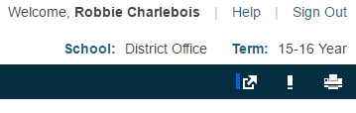
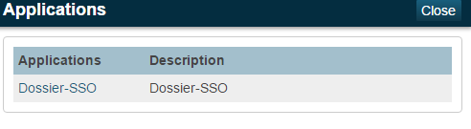
- On the dark bar that goes across the page, on the RIGHT, there is this symbol (an arrow)

- Click on the symbol. There will be a drop down. Click on Dossier-SSO. This will open up the main page that looks like this:
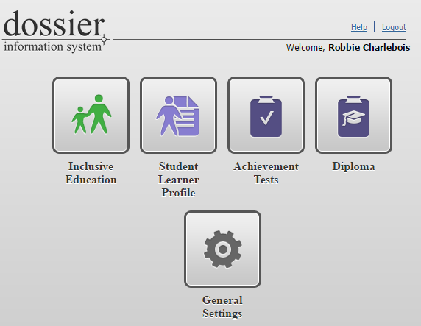

- Click on Student Learner Profile
- Click on Students.
- Click on the name or search for the student for whom you want to make an ISP. You will get to a General Information page.
- Record their F&P Benchmark Results for Fall & Spring. (We do a mid-year benchmark before the second report card. This result does NOT have to be entered on the ISP)

HOW TO FILL OUT THE F&P Section
  - Click on Fountas & Pinnell
  - Click on ADD TEST RESULT
  - Do all the sections that have a red exclamation point.
  - SAVE. You have now completed the F&P section.
If your students have the ELL Code:

HOW TO FILL OUT THE ELL SECTION
- Click on ELL Benchmark
- Click on Add Item.
- Enter the Track Date.
- Enter the Grade Level Division. This will open the various sections.
- Select the levels for the various sub sections. When you click on a level, it will give you descriptors to help you decide whether or not that is the level you wish to attach.
- Remember to SAVE after each section. You have now completed the ELL section. And you have completed your ELL Benchmarking, unless your students require specific instructional strategies and supports. Then see information on next page.
CREATING THE ISP
Students coded Mild/Moderate(you have your beginning of the school list at the top of the page. If students are coded within the year you teach them, add them to the list above and make sure they have an ISP in place, either from the school they transferred in from, or one made by you, the teacher.) You do not have to do the following for students coded ELL except for STUDENTS CODED ELL FOR WHOM YOU ARE USING SPECIFIC INSTRUCTIONAL STRATEGIES AND SUPPORTS. Do just the: SPECIFIC INSTRUCTIONAL STRATEGIES AND SUPPORTS section.
Leave the page you are on by clicking on the word dossier to the left of the students icon. This will bring you back to the main page.
- Click on Inclusive Education
- Click on Students. Click on the name or search for the student for whom you want to make an ISP. You will get to a General Information page.
Click on ISP: with the date of the school year you are presently in. This will open a page with Summary ISP information and below it a list which includes:
  - Educational Information
  - Specialized Assessments
  - Classroom Assessment and Level of Achievement
  - Strengths and Interests
  - Current Supports and Services
  - Accommodations
  - Student Background information
  - Individual Goals
  - Reflection/Transition (at the end of the year) - This is important information to fill out to be passed on to next year’s learning team
- Below the list above (A-I) are three areas
  - Instructional Strategies and Supports
  - Attach Student Documentation
  - Behaviour Plan
The bold faced areas above are the areas that must be filled out for the student with a Mild/Moderate Code.
If you have students on the Severe Code list, you must do all of the bold face above as well as THE INDIVIDUAL GOALS.

SIGNATURES:
ELL ISP’s require …..ONE signature at the beginning of the year and then send home at end of year with reflection/transition filled out. (report card should speak to the strategies and growth/achievement)
MILD/MODERATE ISP’S require…..ONE signature at the beginning of the year and then send home at end of year with reflection/transition filled out. (report card should speak to the strategies and growth/achievement)
SEVERE NEEDS ISP’S require THREE meetings with the parents each year, to go over the student’s programming, as well as signatures at the initial meeting and initials from every meeting, from those people in attendance.

AT THE END OF THE YEAR, ALL ISP’S, ELL’S etc. must be printed out and filed in the student files in the office. The signature page should be attached to this document.

Early Learning ISP’s will be created in Dossier beginning Fall 2016. The same criteria will apply for those students designated a 40 and 30 coding in Early Learning Programs.

