Dossier V4
Teacher User Guide
Created By: Scott Jones
November 9, 2015

Contents
Contents 2
Logging Into Dossier 5
Inclusive Education 6
Profile Section 7
IPP Section 10
B. Testing and Assessment History 12
C. Level of Education Performance and Achievement 12
D. Areas of Strength and Areas to Develop 13
E. School and Community Services 14
F. Assistive Tech, Social Participation Strategies, Accommodations 15
G. Student Background Information 16
H. Goals 16
I. Goals and Objectives 19
J. Reflection/Transition 19
Alberta Education 20
English Language Proficiency Levels 20
Learning Preferences 20
Instructional Strategies and Supports – Template A 21
Instructional Strategies and Supports – Template C 28
Comments and Records 31
Attach Student Documentation 32
Monitoring Checklist 32
1. Supporting documentation from the appropriate professionals(s): 32
2. Please describe how the condition/disability affects the student in the learning environment: 32
3. Services provided: 33
4. Individualized Program Plan (IPP): 36
All Service Costs for Student 36
Grade Level of Achievements 37
Grade Level of Achievements 37
Student Learner Profile 38
General Information 39
Basic Information 39
Student Indicators 39
Student Achievement 40
Provincial Achievement Test 40
Jerry Johns 40
Fountas & Pinnell 1 41
Fountas & Pinnell 2 42
Fountas & Pinnell 3 43
OCA Reading 45
Kindergarten Literacy 46
PM Benchmark 47
Literacy Intervention 47
Early Intervention – French 48
ESL Benchmark 49
GB + 70
Classroom Profile 71
Comments 71
Diploma 72
Select Filter 72
Report Level 73
General 73
Categories 79

Logging Into Dossier

- Going to your Dossier website will present you with the login screen.
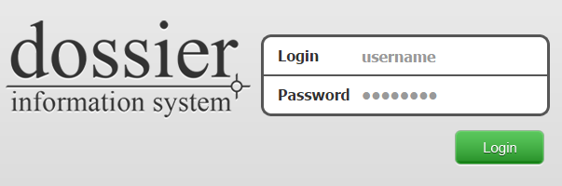
- Enter your Username and Password. Hit enter or click Login.
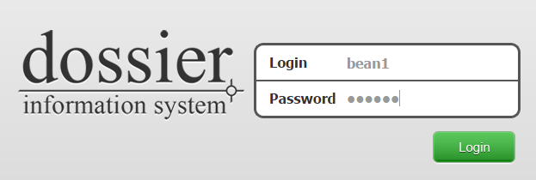
- After successfully logging in, you will be presented with the home screen showing the available sections.
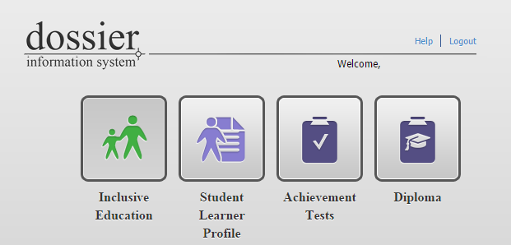

Inclusive Education

- After clicking the Inclusive Education icon, a couple of options will be available at the top of the screen.
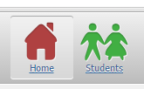

- Click on the Students icon.
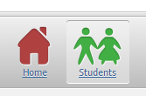
- A list of currently assigned students will load.
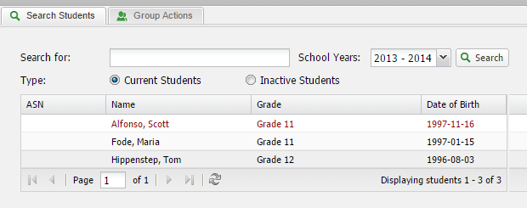
- One thing to note is some students will be a different color than others. This is a visual representation to identify what indicator the student has:
  - Red: Coded
  - Blue: Not coded but with an ISP Creation date
  - Green: ESL
  - Black: Not coded and no ISP, also not ESL

- This list has some search functionality to find specific students:
  - Searching for a specific student by First Name, Last Name, or Student Number.
  - Switching school years to find historical data.
  - Switching between Active and Inactive students.
- Select a student by clicking on their record in the student list.
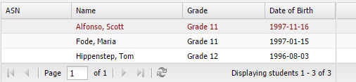
- The page will reload with an additional tab for the selected student.
Clicking on the Search Students tab will return you to the student list screen in 5. Clicking on more students will also load a tab for each student selected so you can switch between students at this level.

Profile Section
- By default, the Profile section of the student is opened after selecting a student with the Main Info displayed.
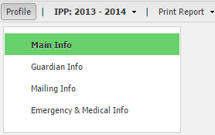
  - Main Info: This screen displays all the information to identify the selected student. Such as Name, Address, Date of Birth, Gender, etc
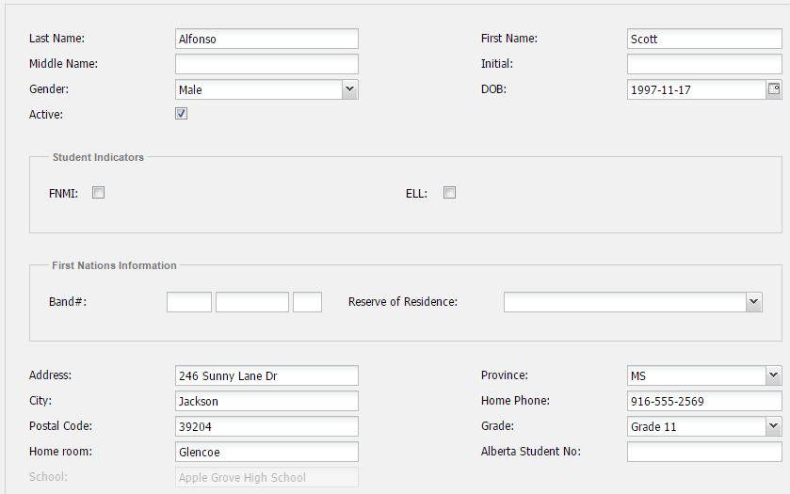
  - Guardian Info: This screen displays the Parent/Guardian contact information for the selected student. 3 separate contacts can be saved along with who the student lives with.
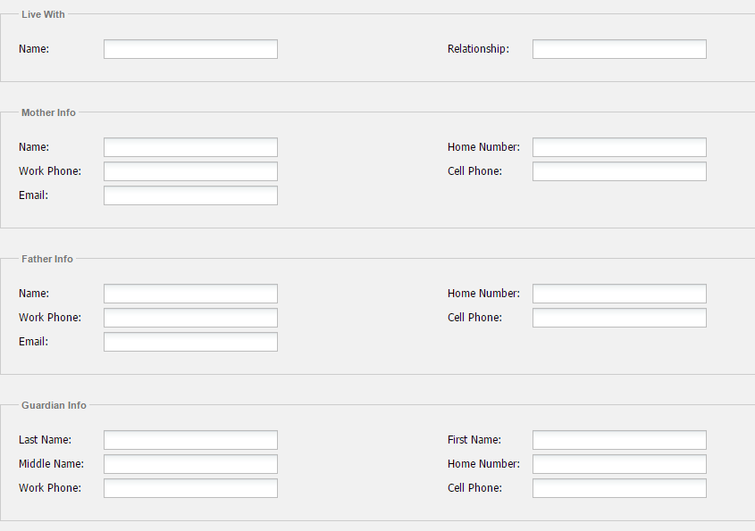
  - Mailing Info: This screen display the saved Mailing Address for the selected student.
  - Emergency & Medical Info: This screen displays 2 separate Emergency contact information and necessary Medical information for the selected student.
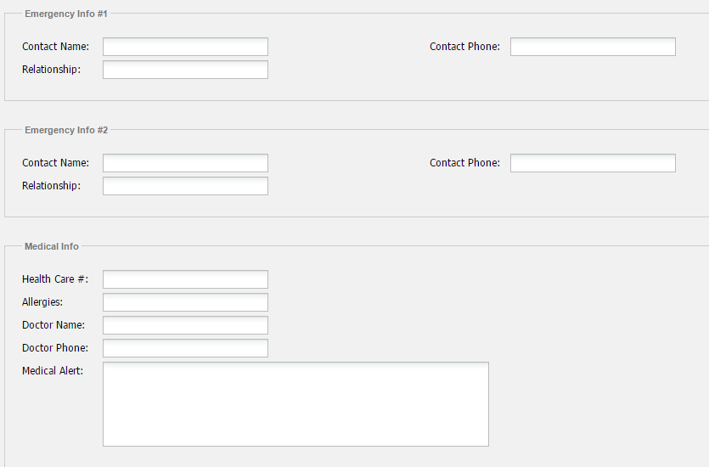

IPP Section
Selecting the IPP tab will open the IPP section for the student. Clicking the down arrow to the right will allow you to load IPP data from previous years if it exists.
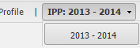
After selecting a student’s IPP, a new screen will load with a menu to the left containing all sub-sections.
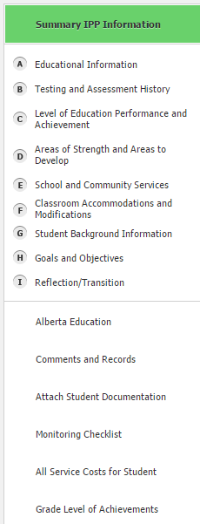
A. Educational Information
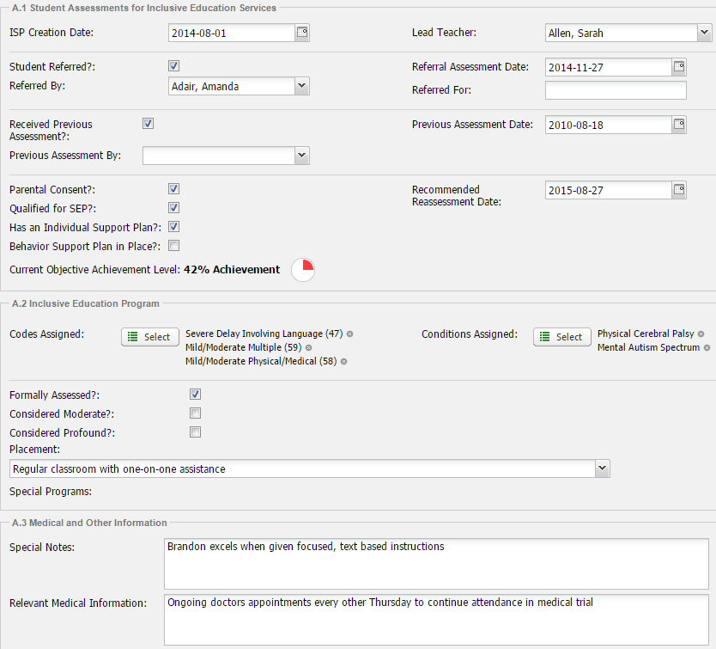
- A.1 Student Assessments for Inclusive Education Services
- IPP Creation Date: Date of when the IPP was first created.
- Lead Teacher:
- Student Referred?:
- Referred By: Person who referred the student.
- Referral Assessment Date: Date of when the student was referred.
- Referred For:
- Received Previous Assessment? Has the previous assessment been received?
- Previous Assessment By: Person who completed previous assessment.
- Previous Assessment Date: Date of the previous assessment.
- Parental Consent?:
- Qualified for SEP?:
- Has an Individual Program/Education Plan?:
- Behavior Support Plan in Place?:
- Recommended Reassessment Date: Date of when next reassessment is recommended.
- Current Objective Achievement Level:
- A.2 Inclusive Education Program
- Codes Assigned:
- Conditions Assigned:
- Formally Assessed?:
- Considered Moderate?:
- Considered Profound?:
- Placement:
- Special Programs:
- A.3 Medical and Other Information
- Special Notes:
- Relevant Medical Information:

B. Testing and Assessment History
- Show all records: Toggles visibility of all Testing and Assessment records.
- Test Name: Name of the test assessment.
- Result: End result or outcome of the test.
- Date: Date the test was completed.
- Add Test Result
  - Test Name: Select the type of test being administered.
    - Other: If Other is selected, describe what test is being administered.
  - Date: The date of when the test was completed.
  - Code:
  - Result:
  - Administrator Name:
  - Administrator Position:
  - Entered By: The person who is creating the test. Automatically filled in.

C. Level of Education Performance and Achievement
- Assessments: Type of assessment(s) that have been conducted.
- Result: The end result of each assessment.
- Date Performed: The date the assessment was completed.
- Add A LEPA Entry
  - Assessment Name: Select the type of assessment being administered.
    - Other: If Other is selected, describe what assessment is being administered
  - Date Performed: Actual date of when the assessment was completed.
  - Result: The actual result from the completed assessment.
  - Description:

D. Areas of Strength and Areas to Develop
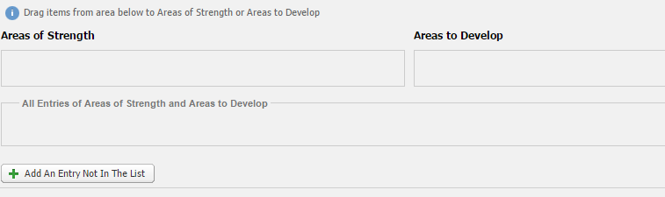
- Areas of Strength
- Areas to Develop
- All Entries of Areas of Strength and Areas to Develop
- Add An Entry Not In The List
  - Name: Name of new Strength or Interest
  - Description: A short description of this newly created item.
  - Comments: A short comment about this entry regarding the student.

- To add an item under Strengths or Interests, click and hold on an item under All Entries of Strengths and Interests. Items can be moved from one category to another as well.
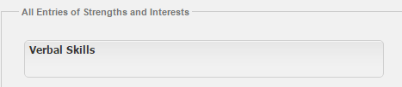
- Drag the item under the proper category and drop.
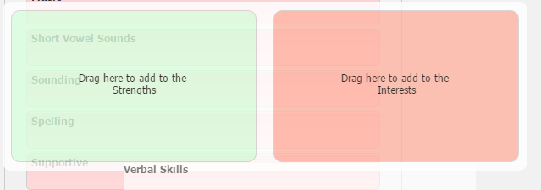
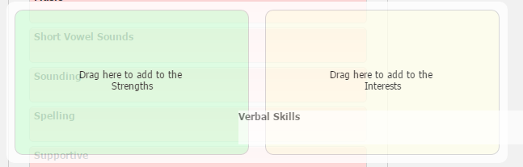
- After dropping the item into the category, it will appear in the respective list.
- Clicking on any item text in the list will open a textbox so a comment can be added.
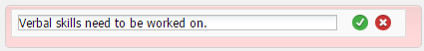
- Clicking the green check mark will save, clicking the red X will cancel changes.

E. School and Community Services
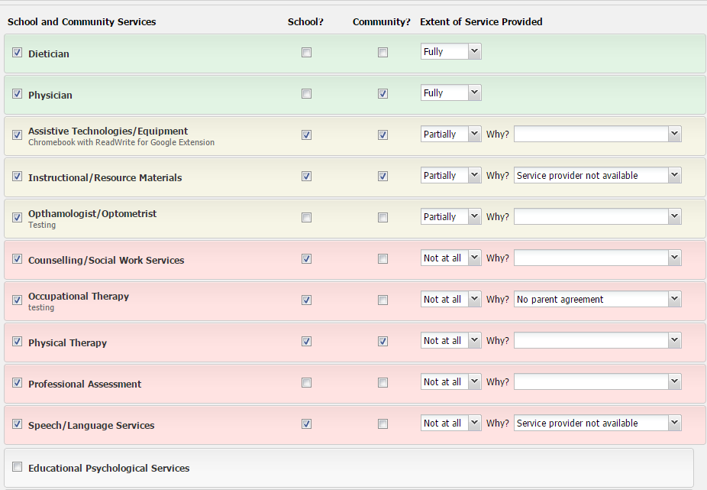
- School and Community Services
  - This list will contain the default items that are setup for the District so the list can be different from District to District. New items can be added for the student by clicking on Add An Entry Not In The List.
- School? –
- Community? –
- Extent of Service Provided –
  - Why?:
- Add An Entry Not In The List
  - Description: Name of the new item to add to the student’s list.
  - Comments: Short optional comment to help describe why the item was added.

F. Assistive Tech, Social Participation Strategies, Accommodations

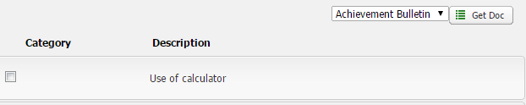
- Documents (Get Doc)
  - Achievement Bulletin
  - Diploma Bulletin
- Category: The category the specific item falls under.
- Description: Descriptive title of the item in the list.
- Comment: Clicking on the Description text will open a text box to enter a comment regarding that item.
- Add An Entry Not In The List
  - Name:
  - Description:
  - Comments:

G. Student Background Information
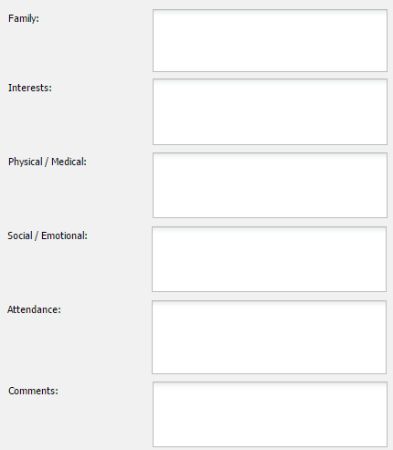
- Family: Description of the student’s family and other important details.
- Interests:
- Physical / Medical: Any Physical or Medical information that is important.
- Social / Emotional: Any Social or Emotional information that is important.
- Attendance: A description of the student’s attendance.
- Comments:

H. Goals
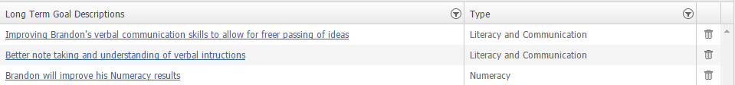
- Long Term Goal Description: Description of what the Long Term Goal is.
- Type: The Category the Long Term Goal is under.
- Add New Goal:
  - Type: The type of Goal being added. Each type selected has slightly different options to fill out:
    - Literacy and Communication:
      - Sub Categories:
        - Reading
        - Listening & Speaking
        - Working with Others
        - Writing
        - Viewing & Representing
      - Current Levels of Performance:
      - Long Term Goal Descriptions:
      - Insert a Goal from the Comment Bank:
      - Display Order:
      - Related Learner Outcomes:
      - This individual Learning Goal:
        - Is personally meaningful.
        - Is socially relevant.
        - Is age respectful.
        - Is developmentally appropriate.
        - Promotes personal autonomy.
        - Creates opportunities to interact with peers.
      - Success Indicator:
      - Mid-year:
      - End of Year:
      - Use direct teaching, modeling and guided practice and small group and individualized instruction to:
        - Build background Knowledge.
        - Develop vocabulary.
        - Access information in multiple ways.
        - Develop word recognition strategies.
        - Develop reading comprehension strategies
        - Express learning in multiple ways.
        - Develop word production strategies.
        - Develop writing strategies.
        - Develop interpersonal skills.
    - Numeracy
      - Current Levels of Performance:
        - Sub Categories:
          - Number Sense
      - Long Term Goal Descriptions:
      - Insert a Goal from the Comment Bank:
      - Display Order
      - Related Learner Outcomes:
      - This individual Learning Goal:
        - Is personally meaningful.
        - Is socially relevant.
        - Is age respectful.
        - Is developmentally appropriate.
        - Promotes personal autonomy.
        - Creates opportunities to interact with peers.
      - Success Indicator:
      - Mid-year:
      - End of Year:
      - Use direct teaching, modeling and guided practice and small group and individualized instruction to:
        - Create hands-on multisensory activities to introduce and explore new mathematics concepts and/or experiences.
        - Support development of vocabulary related to numbers.
        - Explore, discuss and record how numbers are used in the physical environment at school, at home and in the community.
        - Have access to mathematics material and visual prompts that are modified for ease of use.
        - Create and use visual records from previous learning experiences, using photos, anchor charts and experience charts.
        - Explore and record number operations and basic mathematics concepts, using visual prompts, concrete objects, pictures, photos and dramatizations.
    - Other
      - Current Levels of Performance:
      - Long Term Goal Descriptions:
      - Insert a Goal from the Comment Bank:
      - Display Order:
      - Related Learner Outcomes:
      - This individual Learning Goal:
        - Is personally meaningful.
        - Is socially relevant.
        - Is age respectful.
        - Is developmentally appropriate.
        - Promotes personal autonomy.
        - Creates opportunities to interact with peers.
      - Success Indicator:
      - Mid-year:
      - End of Year:

I. Goals and Objectives
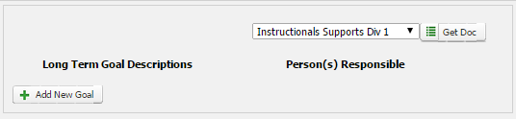
- Documents (Get Doc)
  - Instructionals Supports Div 1
  - Instructionals Supports Div 2
  - Instructionals Supports Div 3 / 4

J. Reflection/Transition
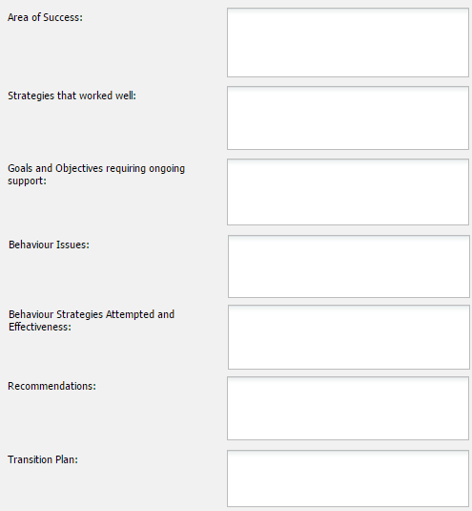
- Area of Success:
- Strategies that worked well:
- Goals and Objectives requiring ongoing support:
- Behaviour Issues:
- Behaviour Strategies Attempted and Effectiveness:
- Recommendations:
- Transition Plan:

Alberta Education

English Language Proficiency Levels
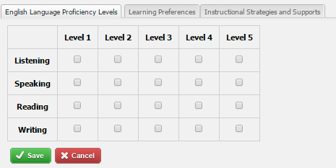
- Listening
- Speaking
- Reading
- Writing

Learning Preferences
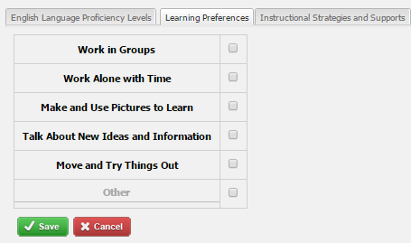
- Work in Groups –
- Work Alone with Time –
- Make and Use Pictures to Learn –
- Talk About New Ideas and Information –
- Move and Try Things Out –
- Other -

Instructional Strategies and Supports – Template A
Checking off any of the following options displays a category to select from and a textbox to enter a comment.
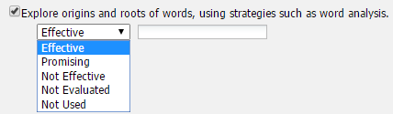

Reading

Develop vocabulary
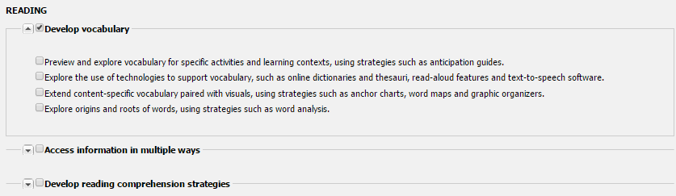
- Preview and explore vocabulary for specific activities and learning context, using strategies such as anticipation guides. –
- Explore the use of technologies to support vocabulary, such as online dictionaries and thesauri, read-aloud features and text-to-speech software. -
- Extend content-specific vocabulary paired with visuals, using strategies such as anchor charts, word maps and graphic organizers. –
- Explore origins and roots of words, using strategies such as word analysis. -

Access information in multiple ways
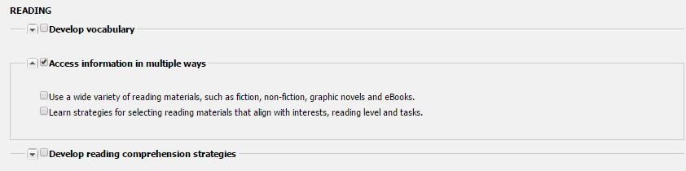
- Use a wide variety of reading materials, such as fiction, non-fiction, graphic novels and eBooks. –
- Learn strategies for selecting reading materials that align with interested, reading level and tasks. -

Develop reading comprehension strategies
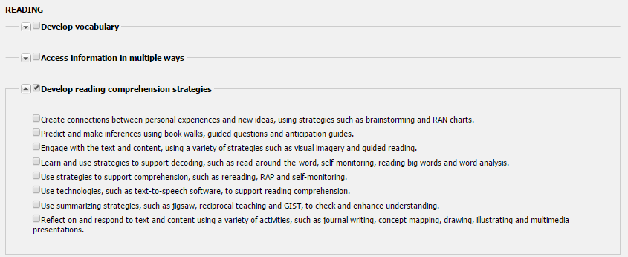
- Create connections between personal experiences and new ideas, using strategies such as brainstorming and RAN charts. –
- Predict and make inferences using book walks, guided questions and anticipation guides. -
- Engage with the text and content, using a variety of strategies such as visual imagery and guided reading. -
- Learn and use strategies to support decoding, such as read-around-the-world, self-monitoring, reading big words and word analysis. -
- Use strategies to support comprehension, such as rereading, RAP and self-monitoring. -
- Use technologies, such as text-to-speech software, to support reading comprehension. -
- Use summarizing strategies, such as jigsaw, reciprocal teaching and GIST, to check and enhance understanding. -
- Reflect on and respond to text and content using a variety of activities, such as journal writing, concept mapping, drawing, illustrating and multimedia presentations. -

Writing

Build background knowledge
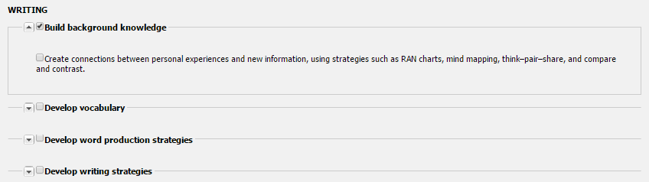
- Create connections between personal experiences and new information, using strategies such as RAN charts, mind mapping, think-pair-share, and compare and contrast. -

Develop vocabulary
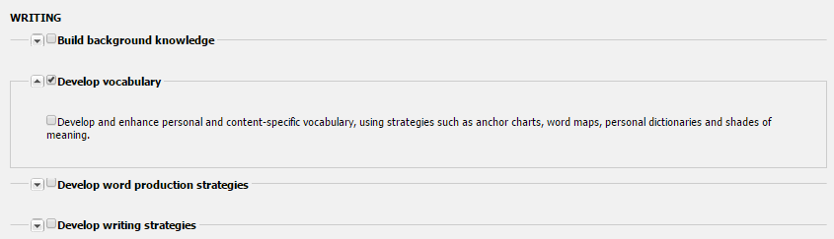
- Develop and enhance personal and content-specific vocabulary, using strategies such as anchor charts, word maps, personal dictionaries and shades of meaning. -

Develop word production strategies
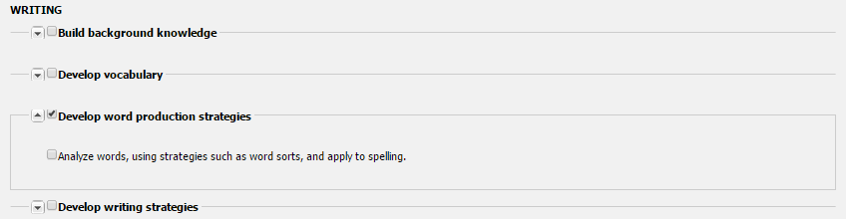
- Analyze words, using strategies such as word sorts, and apply to spelling. -

Develop writing strategies
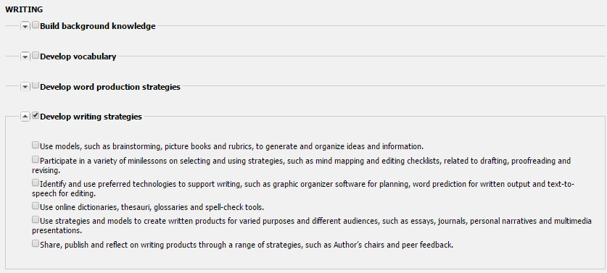
- Use models, such as brainstorming, picture books and rubrics, to generate and organize ideas and information. –
- Participate in a variety of mini-lessons on selecting and using strategies, such as mind mapping and editing checklists, related to drafting, proofreading and revising. –
- Identify and use preferred technologies to support writing, such as graphic organizer software for planning, word prediction for written output and test-to-speech for editing. –
- Use online dictionaries, thesauri, glossaries and spell-check tools. –
- Use strategies and models to create written products for varied purposes and different audiences, such as essays, journals, personal narratives and multimedia presentations. –
- Share, publish and reflect on writing products through a range of strategies, such as Author’s chairs and peer feedback. -

Speaking & Listening

Build background knowledge
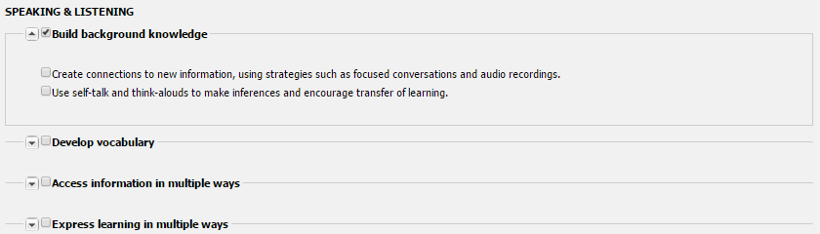
- Create connections to new information, using strategies such as focused conversations and audio recordings. –
- Use self-talk and think-alouds to make inferences and encourage transfer of learning. -

Develop vocabulary
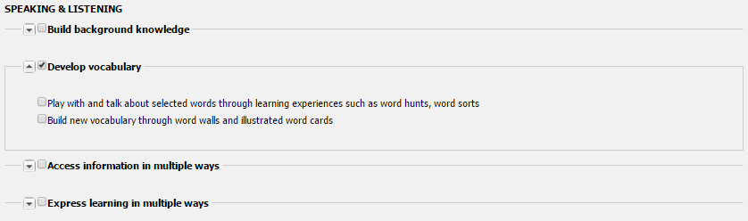
- Play with and talk about selected words through learning experiences such as word hunts, word sorts. –
- Build new Vocabulary through word walls and illustrated word cards. -

Access information in multiple ways
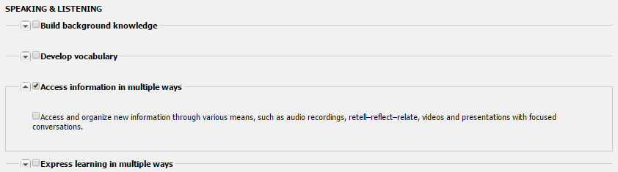
- Access and organize new information through various means, such as audio recordings, retell-reflect-relate, videos and presentations with focused conversations. -

Express learning in multiple ways
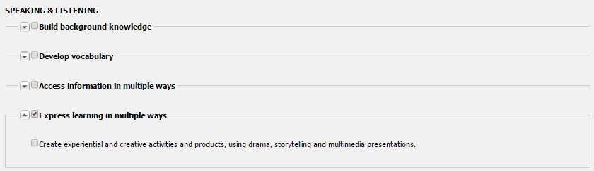
- Create experiential and creative activities and products, using drama, storytelling and multimedia presentations. -

Viewing & Representing

Access information in multiple ways
- Create and review visual records from previous learning activities, using strategies such as photo diaries, videos and anchor charts. –
- Access and explore new information from visual resources, such as picture books, photo collections, posters, videos and demonstrations. -

Express learning in multiple ways
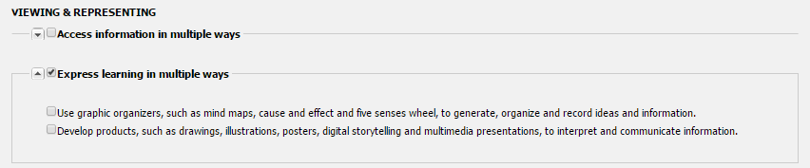
- Use graphic organizers, such as mind maps, cause and effect and five senses wheel, to generate, organize and record ideas and information. –
- Develop products, such as drawings, illustrations, posters, digital storytelling and multimedia presentations, to interpret and communicate information. -

Working With Others

Develop interpersonal skills
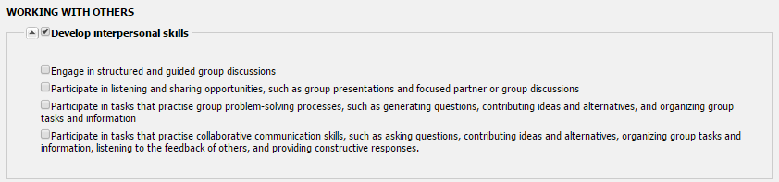
- Engage in structured and guided group discussions. –
- Participate in listening and sharing opportunities, such as group presentations and focused partner or group discussions. –
- Participate in tasks that practice group problem-solving processes, such as generating questions, contributing ideas and alternatives, and organizing group tasks and information. –
- Participate in tasks that practice collaborative communication skills, such as asking questions, contributing ideas and alternatives, organizing group tasks and information, listening to the feedback of others, and providing constructive responses. -

Math

Universal
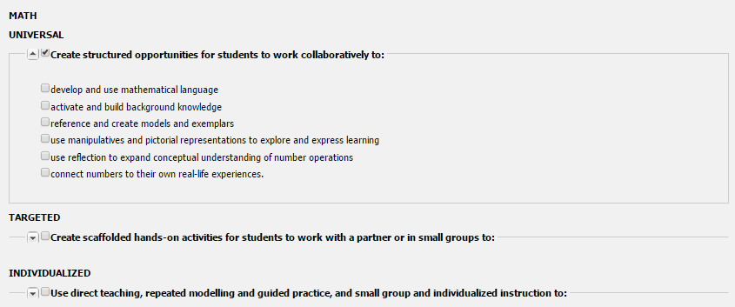
- Develop and use mathematical language. –
- Activate and build background knowledge. –
- Reference and create models and exemplars. –
- Use manipulatives and pictorial representations to explore and express learning. –
- Use reflection to expand conceptual understanding of number operations. –
- Connect numbers to their own real-life experiences. -

Targeted
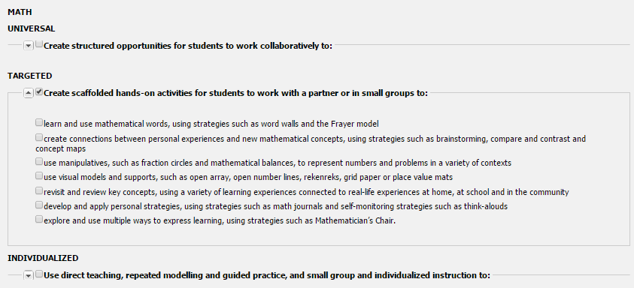
- Learn and use mathematical words, using strategies such as word walls and the Frayer model. –
- Create connections between personal experiences and new mathematical concepts, using strategies such as brainstorming, compare and contrast and concept maps.
- Use manipulatives, such as fraction circles and mathematical balances, to represent numbers and problems in a variety of contexts. –
- Use visual models and supports, such as open array, open number lines, rekenreks, grid paper or place value mats. –
- Revisit and review key concepts, using a variety of learning experiences connected to real-life experiences at home, at school and in the community. –
- Develop and apply personal strategies, using strategies such as math journals and self-monitoring strategies such as think-alouds. –
- Explore and use multiple ways to express learning, using strategies such as Mathematician’s Chair. –

Individualized

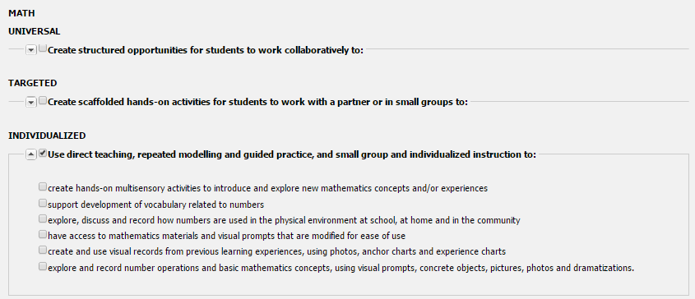
- Create hands-on multisensory activities to introduce and explore new mathematics concepts and/or experiences. –
- Support development of vocabulary related to numbers. –
- Explore, discuss and record how numbers are used in the physical environment at school, at home and in the community. –
- Have access to mathematics materials and visual prompts that are modified for ease of use. –
- Create and use visual records from previous learning experiences, using photos, anchor charts and experience charts. –
- Explore and record number operations and basic mathematics concepts, using visual prompts, concrete objects, pictures, photos and dramatizations. -

Instructional Strategies and Supports – Template C
Checking off any of the following options displays subject selection where multiples subjects can be associated, a category to select from, and a textbox to enter a comment.
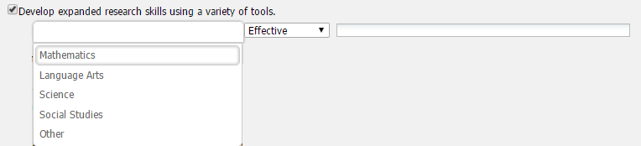

Changes to Content
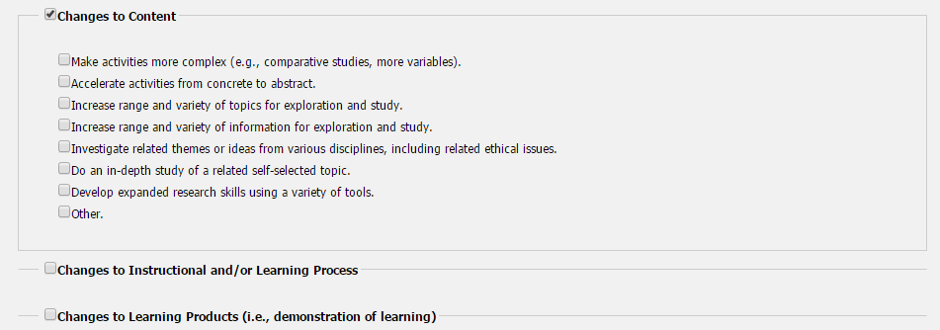
- Make activities more complex (e.g., comparative studies, more variables).
- Accelerate activities from concrete to abstract.
- Increase range and variety of topics for exploration and study.
- Increase range and variety of information for exploration and study.
- Investigate related themes or ideas of various disciplines, including related ethical issues.
- Do an in-depth study of a related self-selected topic.
- Develop expanded research skills using a variety of tools.
- Other

Changes to Instructional and/or Learning Process
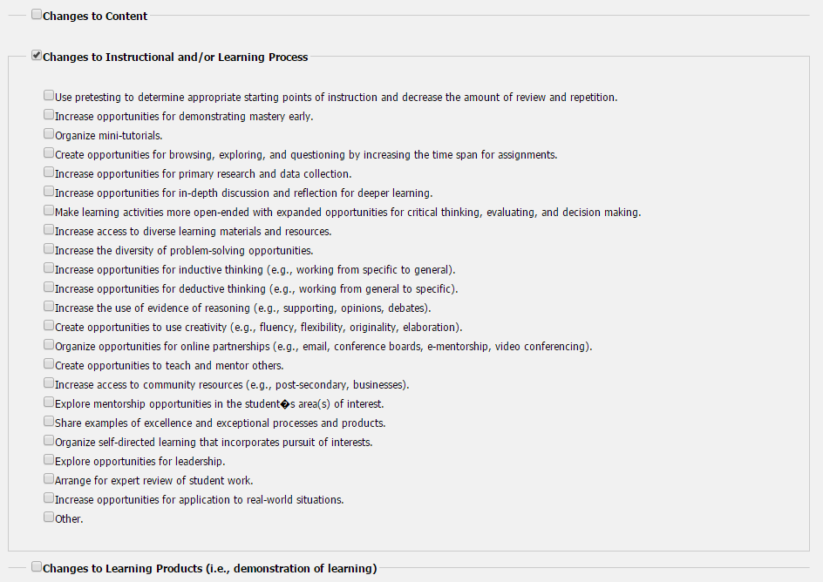
- Use pretesting to determine appropriate starting points of instruction and decrease the amount of review and repetition.
- Increase opportunities for demonstrating mastery early.
- Organize mini-tutorials.
- Create opportunities for browsing, exploring, and questioning by increasing the time span for assignments.
- Increase opportunities for primary research and data collection.
- Increase opportunities for in-depth discussion and reflection for deeper learning.
- Make learning activities more open-ended with expanded opportunities for critical thinking, evaluating, and decision making.
- Increase access to diverse learning materials and resources.
- Increase the diversity of problem-solving opportunities.
- Increase opportunities for inductive thinking (e.g., working from specific to general).
- Increase opportunities for deductive thinking (e.g., working from general to specific).
- Increase the use of evidence of reasoning (e.g., supporting, opinions, debates).
- Create opportunities to use creativity (e.g., fluency, flexibility, originality, elaboration).
- Organize opportunities for online partnerships (e.g., email, conference boards, e-mentorship, video conferencing).
- Create opportunities to teach and mentor others.
- Increase access to community resources (e.g., post-secondary, businesses).
- Explore mentorship opportunities in the student’s area(s) of interest.
- Share examples of excellence and exceptional processes and products.
- Organize self-directed learning that incorporates pursuit of interests.
- Explore opportunities for leadership.
- Arrange for expert review of student work.
- Increase opportunities for application to real-world situations.
- Other.

Changes to Learning Products (i.e., demonstration of learning)
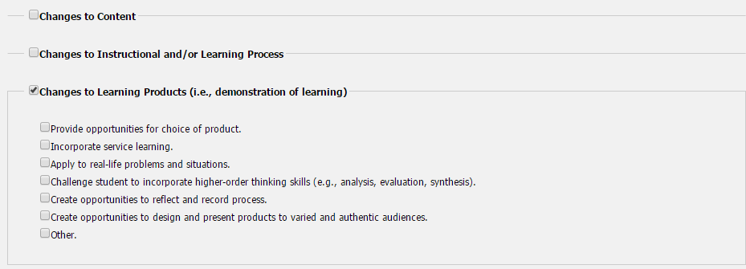
- Provide opportunities for choice of product.
- Incorporate service learning.
- Apply to real-life problems and situations.
- Challenge student to incorporate higher-order thinking skills (e.g., analysis, evaluation, synthesis).
- Create opportunities to reflect and record process.
- Create opportunities to design and present products to varied and authentic audiences.
- Other.

Additional Information to Inform Planning: Potential junior high courses, options, or extra-curricular opportunities that could offer optimal challenge for this student:
This area is for identifying and important information that isn’t in the other sections. Such as sections/courses that could be good for the student to take in the future.

Comments and Records

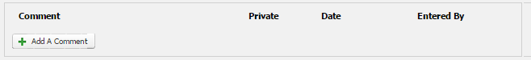
- Comments. –
- Private. –
- Date. –
- Entered By. -
- Add A Comment
  - Comment:
  - Private:

Attach Student Documentation
- Document. –
- Type. –
- Description. –
- Date. –
- Upload Student IPP Document
  - File:
  - Description:
  - Type:

Monitoring Checklist

Supporting documentation from the appropriate professionals(s):
Describe additional assessment information for this report above and beyond the assessments themselves (assessments are located in Student Testing History):
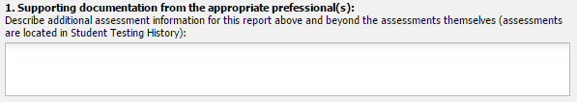

Please describe how the condition/disability affects the student in the learning environment:
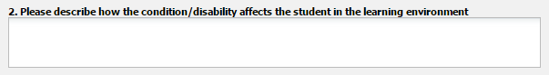

Services provided:

Section A: Frequent specialized one-on-one intervention
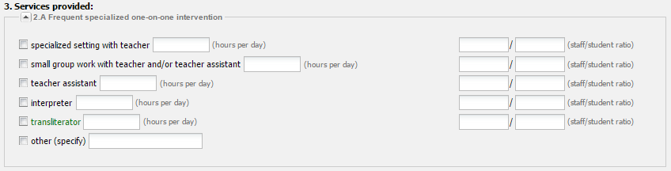
- Specialized settings with teacher. –
- Small group work with teacher and/or teacher assistant. –
- Teacher assistant. –
- Interpreter. –
- Transliterator. –
- Other (speicify). –

Section B: Specialized equipment and/or assistive devices
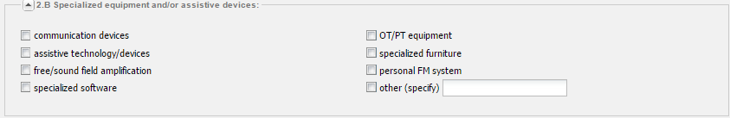
- Communication devices. –
- Assistive technology/devices. –
- Free/sound field amplification. –
- Specialized software. –
- OT/PT equipment. –
- Specialized furniture. –
- Personal FM system. –
- Other (specify). –

Section C: Assistance with personal care/health-related interventions
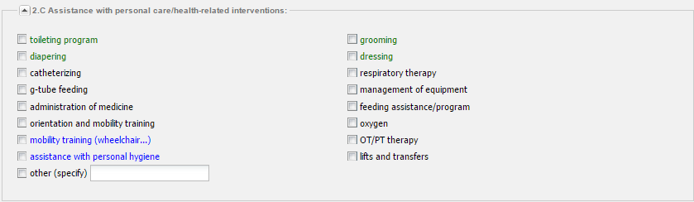
- Toileting program. –
- Grooming. -
- Diapering. –
- Dressing. -
- Catheterizing. –
- Respiratory therapy. -
- G-tube feeding. –
- Management of equipment. -
- Administration of medicine. –
- Feeding assistance/program. -
- Orientation and mobility training. –
- Oxygen. -
- Mobility training (wheelchair…). –
- OT/PT therapy. -
- Assistance with personal hygiene. –
- Lifts and transfers. -
- Other (specify). –

Section D: Frequent documentation of behavioural and/or medical status:
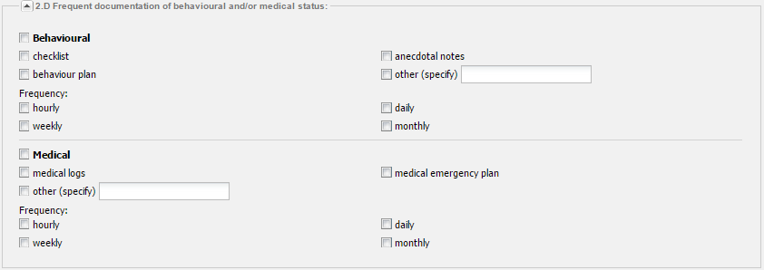
Behavioural. –
- Checklist. –
- Anecdotal notes. –
- Behaviour plan. –
- Other (specify). –
Frequency
- Hourly. –
- Daily. –
- Weekly. –
- Monthly. –
Medical. –
- Medial logs. –
- Medical emergency plan. –
- Other (specify). –
Frequency
- Hourly. –
- Daily. –
- Weekly. –
- Monthly. –

Section E: Direct support services for the student at a cost to the system
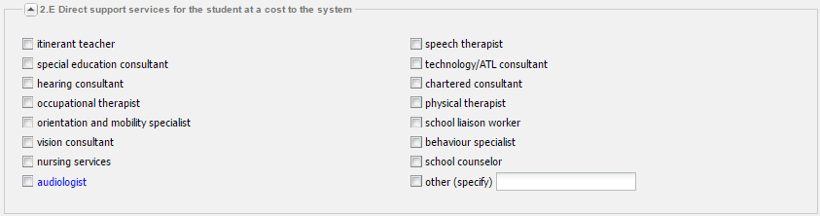
- Itinerant teacher. –
- Speech therapist. –
- Special education consultant. –
- Technology/ATL consultant. –
- Hearing consultant. –
- Chartered consultant. –
- Occupational therapist. –
- Physical therapist. –
- Orientation and mobility specialist. –
- School liaison worker. –
- Vision consultant. -
- Behaviour specialist. –
- Nursing services. -
- School counselor. –
- Audiologist. –
- Other (specify). –

Other service providers not at a cost to the system.
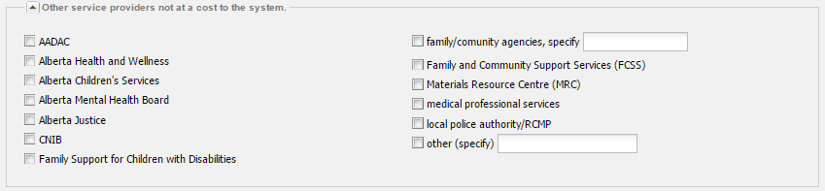
- AADAC. –
- Family/community agencies, specify. -
- Alberta Health and Wellness. –
- Family and Community Support Services (FCSS). –
- Alberta Children’s Services. –
- Materials Resource Center (MRC). –
- Alberta Mental Health Board. –
- Medical Professional Services. –
- Alberta Justice. –
- Local police authority/RCMP. –
- CNIB. –
- Family Support for Children with Disabilities. –
- Other (specify). –

Individualized Program Plan (IPP):
- The current IPP identifies the assessed needs of the student and includes specific educational programming to address those needs.
- This IPP has been developed, implemented and signed by the learning team including the parent/guardian.

All Service Costs for Student
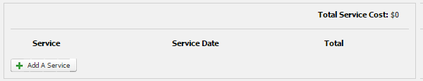
- Total Services Cost. –
- Service. –
- Service Date. –
- Total. –
- Add Service
  - Service:
  - Service Date:
  - Funds Directly Spent From Special Education Budget:
  - Funds Spent From Other School Budgets:
  - Funds Spent from Other Sources:
  - Comment:

Grade Level of Achievements
- Foundational skills - e.g., communications, classroom behaviour, gross and fine motor skills
- Academic readiness skills - e.g., readiness skills to prepare student for learning outcomes in the programs of study in Grade 1 and subsequent grade levels.
- Life skills - e.g., communications, classroom behaviour, gross and fine motor skills

Grade Level of Achievements
- Review Date:
- Key Understandings:
- Antecedent Events:
- Warning Signs:
- Plans to Defuse:
- Positive Behavior Supports:
- Help Peers Learn:
- Additional Supports:
- Crisis Management Plan:

Student Learner Profile

- After clicking the Student Learner Profile icon, a couple of options will be available at the top of the screen with Students being selected by Default
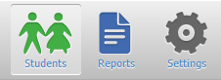

- From here, simply select a student to load their Achievement testing records. The user can also search for the specific students by using the searching parameters above the student list.
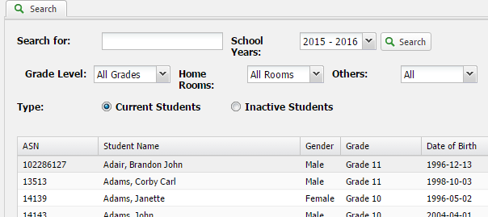

- After clicking a student in the list, the achievement testing area for the student will load. The left menu contains all of the achievement testing that is in the system. Note that this may be different from District to District.
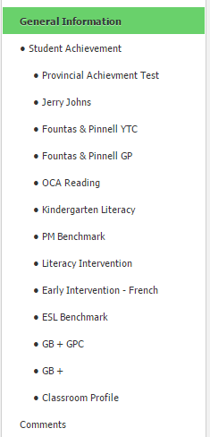

General Information

Basic Information
This section contains the basic information to identify the students. Such as Name, Date of Birth, Age, etc..
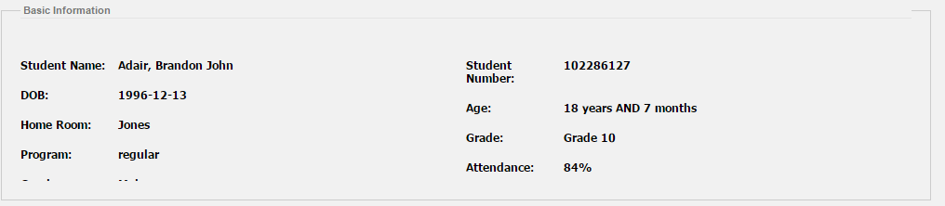

Student Indicators
Identifies what indicators the student currently has.
- FNMI:
- ELL:
- HCS:

Student Achievement

Provincial Achievement Test

Provincial Achievement Test Results
This area identifies the results of both Math and LA PAT results for Grade 3, Grade 6, and Grade 9. To the right of this information is a chart to show a visual representation of these results.
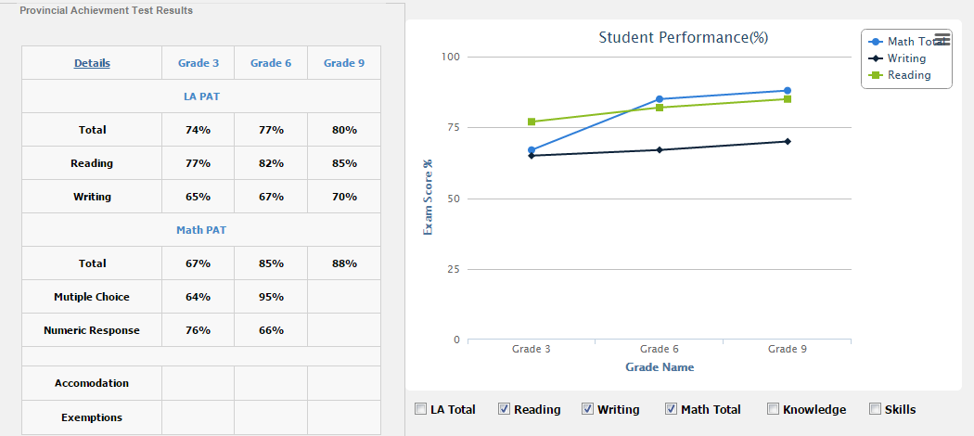

Jerry Johns
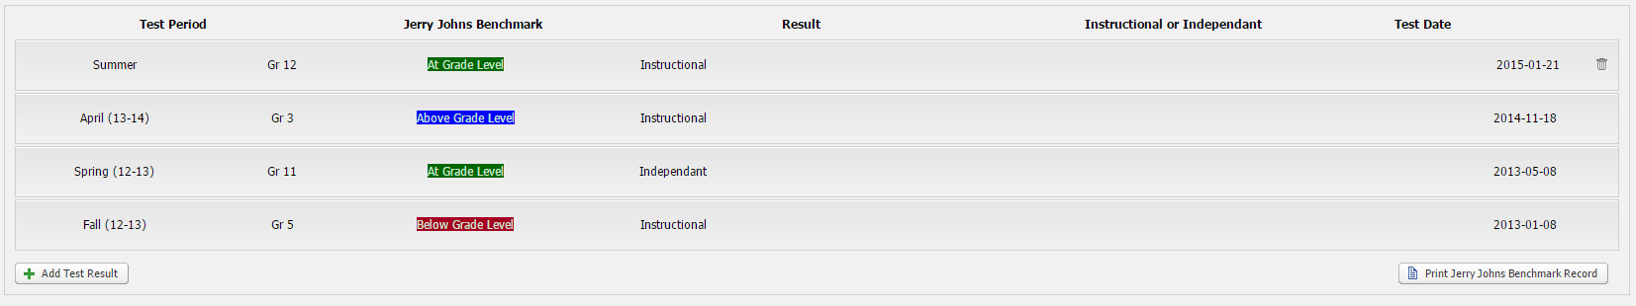
- Test Period: Period the testing was conducted. Typically Summer, Spring, Fall, or Winter.
- Jerry Johns Benchmark: Identifies the grade level the student achieved at. This section also is color code: Above Grade Level , At Grade Level , Below Grade Level
- Instructional or Independent: Describes where the student is after completing the testing.
- Test Date: Actual date the testing was conducted.
  - Add Test Result
    - Jerry Johns Benchmark
    - Instructional or Independent
    - Date of Test
    - Period Name

Fountas & Pinnell 1
This area contains a table that will show all achievement records for Fountas & Pinnell 1.
- Test Periods : Test period of this achievement testing.
- Highest Reading Level : The highest level of reading.
- Result : The end result for the achievement testing.
- Teacher’s Name : Name of teacher who entered the record.
To add a new record, simply click . All fields are mandatory except for the Comments field.
- Add Test Result :
  - Test Month : 2 test months, October or June.
  - Highest Instructional Level :
    - A - Z
  - Independent Level :
    - A - Z
  - Fluency Level :
    - 0 - 3
  - Self-Correction rate :
    - NCSR
    - 0
    - 1:1
    - 1:2
    - 1:3
    - 1:4
    - 1:5 or more
  - Accuracy Score :
    - Below 90%
    - 91%
    - 92%
    - 93%
    - 94%
    - 95%
    - 96%
    - 97%
    - 98%
    - 99%
  - Comprehension Score :
    - U
    - L
    - S
    - E
  - Reading Level Goal :
    - A - Z
  - Comments or Extension Goal :
    - Optional but this area is for any comments or Goals regarding this Achievement record.

Default Settings
By default, here are the settings for Fountas & Pinnell 1.
- Grade 1
  - January: C,D are at grade level
  - June: I,J are at grade level
- Grade 2
  - October: I,J at grade level
  - June: M,N at grade level
- Grade 3
  - October: M,N at grade level
  - June: P,Q at grade level
- Grade 4
  - October: P,Q at grade level
  - June: S,T at grade level
- Grade 5
  - October: S,T at grade level
  - June: V,W at grade level
- Grade 6
  - October: V,W at grade level
  - June: Y at grade level

Fountas & Pinnell 2
This area contains a table that will show all achievement records for Fountas & Pinnell 1.
- Test Periods :
- Reading Level :
- Result :
- Test Date :
To add a new record, simply click
- Add Test Result :
  - F&P Independent Reading :
    - A - Z
  - Test Result :
    - Above Grade Level
    - At Grade Level
    - Below Grade Level
  - Date of Test :
    - Date the assessment was completed.
  - Period Name :
    - Term 1
    - Term 2
    - Term 3
    - Term 4

Default Settings
By default, here are the settings for Fountas & Pinnell 2.
- A : Pre-Kindergarten
- A – D : Kindergarten
- E – J : Grade 1
- K – M : Grade 2
- N – P : Grade 3
- Q – S : Grade 4
- T – V : Grade 5
- W – Y : Grade 6
- Z : Grade 7, 8, and Above
- Z + : Grade 9

Fountas & Pinnell 3
This area contains a table that will show all achievement records for Fountas & Pinnell 1.
To add a new record, simply click
- Test Type :
  - Test
  - Checkin
- Date :
  - Fall
  - Spring
- Date Tested :
  - Date the assessment was completed.
- Independent Level :
  - Not A
  - A – Z
  - Z+
- Accuracy (Independent Level) :
  - 95%
  - 96%
  - 97%
  - 98%
  - 99%
  - 100%
- Comprehension (Independent Level) :
  - 7
  - 8
  - 9
  - 10
- Instructional Level :
  - Not A
  - A – Z
  - Z+
- Accuracy (Instructional Level) :
  - 95%
  - 96%
  - 97%
  - 98%
  - 99%
  - 100%
- Comprehension (Instructional Level) :
  - 7
  - 8
  - 9
  - 10
- Comments :
- Reading Level Goal :
  - A - Z

Default Settings
By default, here are the settings for Fountas & Pinnell 3.
- Check-in:
  - Grade 1: E risk, F approaching, G at
  - Grade 2: J risk, K approaching, K at
  - Grade 3: L risk, N approaching, O at
  - Grade 4: O risk, Q approaching, R at
  - Grade 5: Q risk, T approaching, U at
  - Grade 6: T risk, W approaching, X at
  - Grade 7: W risk, Y approaching, Z at
  - Grade 8: W risk, Y approaching, Z at
- “Not A” will always be at risk
- Z+ will always be at grade level

OCA Reading
The first section shows a chart with each question from the test. Each question will show the difference between questions and test period as shown in the following image.
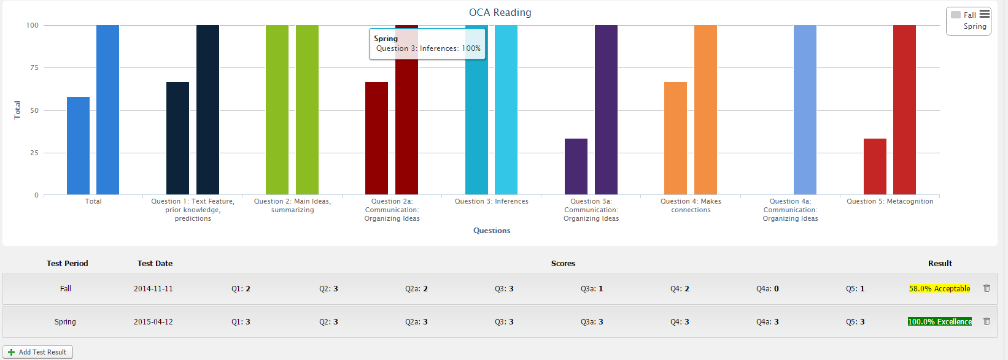
The next section shows the same data from the chart but in table form and also showing the total Result. Clicking on the Test Period for an existing record will open it in edit mode.
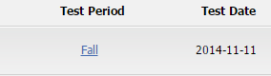

When in edit mode, everything can be updated as needed including the results for each question set. After changes have been made, simply click Save to reset the page to load the new results.
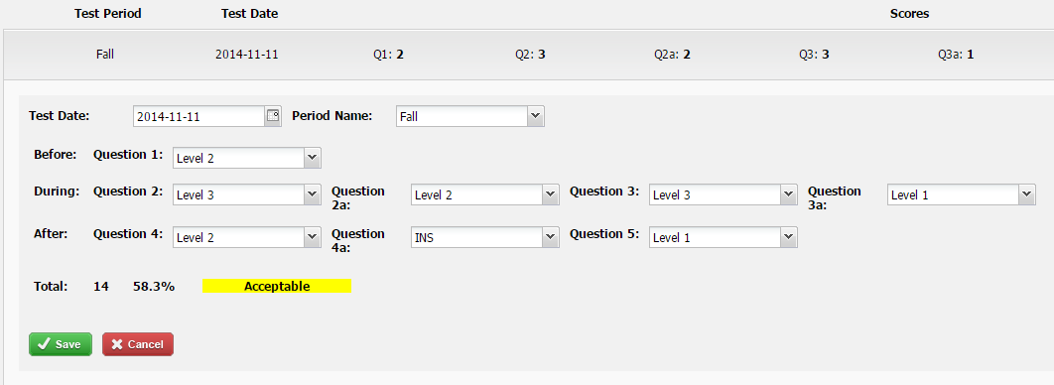
New entries can be added at any time when needed. Clicking on Add Test Result will bring up the same prompt as in Edit mode.
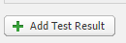

Kindergarten Literacy
To update the Kindergarten Literacy testing scores simply make the appropriate changes and click Save. The page will reload to show the updated calculation.
To remove this record, clear the Test Year textbox and click save. The page will reload showing blank values.
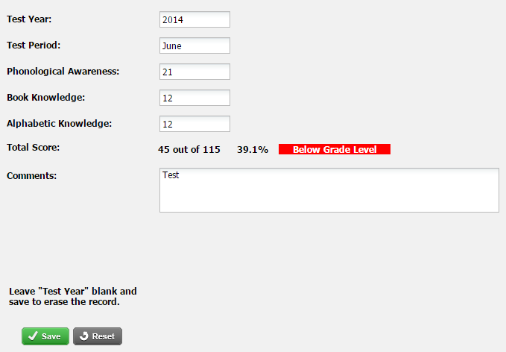
- Test Year: The year the kindergarten literacy testing was completed.
- Test Period: When, or the period the testing was completed.
- Phonological Awareness:
- Book Knowledge:
- Alphabetic Knowledge:
- Total Score: This area is automatically calculated based off of Phonological Awareness, Book Knowledge, and Alphabetic Knowledge values.
- Comments: Any comments that are important to note regarding this test.

PM Benchmark
This section contains 2 areas, a Graph and a Table showing the specific data entered.

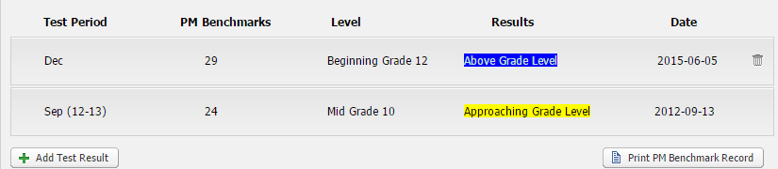
New results can be added by clicking Add Test Result.
- Date of Test: Date the new test was completed.
- Period Name: The month that the new test was conducted.
- PM Benchmark: The actual score the student received for the new test. A number between 1 and 30.
After entering the correct info, clicking on Save will reload the page showing the new record. The Level and Result fields are calculated automatically based off the data entered for the record.

Literacy Intervention
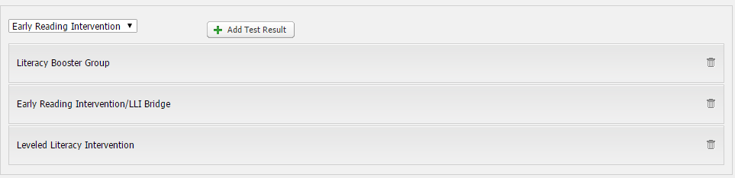
This area lists all of the Literacy Intervention records that have been entered for the student. Each record is based off of 2 category’s, Early Reading Intervention and Soar to Success.
To edit a record, simply click on the category text to open edit mode. Each Category has some different options.
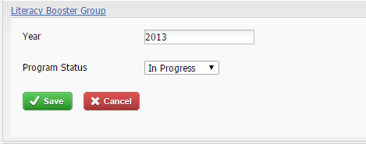

- Soar to Success
  - Year: The year this Literacy Intervention record took place.
  - Program Status: The status of this item.
    - Unsuccessful
    - In Progress
    - Successful
- Early Reading Intervention
  - Year: The year this Literacy Intervention record took place.
  - F & P level:
  - Comprehension Score:
  - Program Status: The status of this item.
    - Unsuccessful
    - In Progress
    - Successful
Once the changes have been made, click on Save to reload the page and the updated values will be represented for the item.
To add a new item, click on Add Test Result. The process is the same as editing an existing item.

Early Intervention – French
Results on this screen can be updated at any time when needed. Filling out the score next to the category and clicking save will automatically calculate the percentage value as seen in the image below.
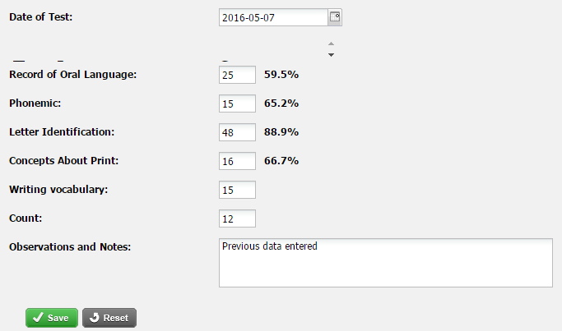
- Date of Test: Date of when the test was completed.
- Record of Oral Language:
- Phonemic:
- Letter Identification:
- Concepts About Print:
- Writing Vocabulary:
- Count:
- Observations and Notes: A comment section to identify anything important regarding this students testing.

ESL Benchmark
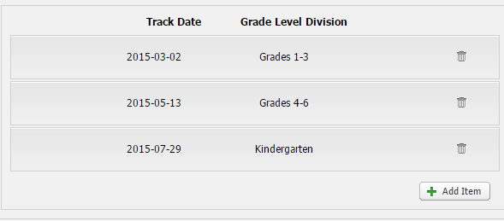
This area consists of 4 Benchmark categories. Clicking an existing record or clicking Add Item will load the following 4 categories.

BENCHMARK – LISTENING
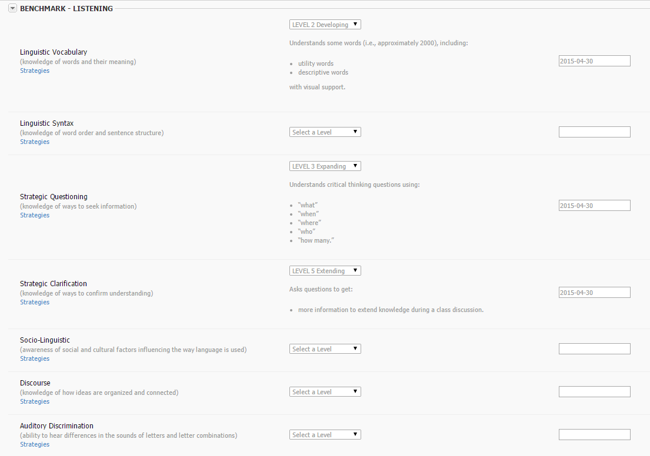
- Linguistic Vocabulary (Knowledge of words and their meaning)
Achievement Levels
  - LEVEL 1 Beginning
    - Understand safe words (i.e., approximately 1500), including:
      - Utility words related to familiar objects.
    - With visual support.
  - LEVEL 2 Developing
    - Understands some words (i.e, approximately 2000), including
      - Utility words
      - Descriptive words
    - With visual support.
  - LEVEL 3 Expanding
    - Understands more words (i.e., approximately 4000), including:
      - Utility words
      - Descriptive words
      - Subject-specific words
  - LEVEL 4 Bridging
    - Understands arrange of words (i.e., approximately 7500), including:
      - Utility words
      - Descriptive words
      - Subject-specific words
      - Academic words
  - LEVEL 5 Extending
    - Understands a broad range of words (i.e., approximately 10,000), including:
      - Utility words
      - Descriptive words
      - Subject-specific words
      - Academic words
- Linguistic Syntax (Knowledge of word order and sentence structure)
  - LEVEL 1 Beginning
    - Understands:
      - Commands
      - Simple phrases associated with familiar routines.
    - With visual support
  - LEVEL 2 Developing
    - Understands:
      - Two-step commands
      - Two-step phrases
      - Simple sentences on familiar topics
    - With visual support
  - LEVEL 3 Expanding
    - Understands:
      - Three-step commands
      - Detailed sentences on familiar topics
    - With visual support
  - LEVEL 4 Bridging
    - Understands:
      - Multi-step directions
      - Complex sentences on familiar topics
    - With minimal support
  - LEVEL 5 Extending
    - Understands:
      - Multi-step directions
      - Complex sentences
      - Compound sentences on unfamiliar topics
    - With minimal support
- Strategic Questioning (knowledge of ways to seek information)
  - LEVEL 1 Beginning
    - Understands:
      - Simple directives
      - “yes/no” questions
      - “either/or” questions
    - Accompanied by visual support
  - LEVEL 2 Developing
    - Understands critical thinking questions using:
      - “what”
      - “when”
      - “where”
      - “who”
      - “how many”
  - LEVEL 3 Expanding
    - Understands critical thinking questions using:
      - “what”
      - “when”
      - “where”
      - “who”
      - “how many”
  - LEVEL 4 Bridging
    - Understands open-ended questions requiring:
      - Explanation
      - Elaboration
      - Comparison
  - LEVEL 5 Extending
    - “If…?”
    - “what if…?”
    - “would you…?”
    - “How…?”
- Strategic Clarification (knowledge of ways to confirm understanding)
  - LEVEL 1 Beginning
    - Requests clarification on using:
      - Gesturing
      - Mimicking
      - Single words
  - LEVEL 2 Developing
    - Request clarification on using:
      - Familiar phrases
  - LEVEL 3 Expanding
    - Requests clarification on using:
      - Simple questions
  - LEVEL 4 Bridging
    - Clarifies understanding by asking:
      - Specific questions
  - LEVEL 5 Extending
    - Asks questions to get:
      - More information to extend knowledge during class discussion
- Socio-Linguistic (awareness of social and cultural factors influencing the ways language is used)
  - LEVEL 1 Beginning
    - Understands:
      - Familiar social expressions
  - LEVEL 2 Developing
    - Understands:
      - Familiar language
      - Expressions
    - Used in classroom and school contexts
  - LEVEL 3 Expanding
    - Recognizes:
      - Differences in formality of speech
    - In familiar contexts
  - LEVEL 4 Bridging
    - Recognizes:
      - Differences in formality of speech
    - In unfamiliar contexts.
  - LEVEL 5 Extending
    - Understands:
      - Common idioms
      - Cultural references
- Discourse (knowledge of how ideas are organized and connected)
  - LEVEL 1 Beginning
    - Understands:
      - A few words in related sentences about familiar topics
    - With visual support
  - LEVEL 2 Developing
    - Understands:
      - The gist of sentences and phrases
    - Connected with:
      - “and” and “then”
    - With visual support
  - LEVEL 3 Expanding
    - Understands:
      - Main ideas in texts on unfamiliar topics
    - Connected with:
      - Common conjunctions
      - Time markers
      - Sequence markers
  - LEVEL 4 Bridging
    - Understands:
      - Main ideas
      - Some details of texts on unfamiliar topics
    - Connected with:
      - Common conjunctions
      - Time markers
      - Sequence markers
  - LEVEL 5 Extending
    - Understands:
      - Detailed explanations of unfamiliar topics
    - Connected with:
      - Conjunctions
      - Time markers
      - Sequence markers
- Auditory Discrimination (ability to hear differences in the sounds of letters and letter combinations
  - LEVEL 1 Beginning
    - Recognizes:
      - Most English phenomes (sounds)
    - Listens for:
      - Recognizable words
  - LEVEL 2 Developing
    - Identifies:
      - Initial sounds in words
    - Distinguishes:
      - Word boundaries
  - LEVEL 3 Expanding
    - Understands:
      - Familiar reduced speech
    - Distinguishes:
      - Minimal pairs
  - LEVEL 4 Bridging
    - Understands:
      - Familiar rapid speech
    - Distinguishes:
      - Words the rhyme
  - LEVEL 5 Extending
    - Understands:
      - Rapid speech from unfamiliar speakers
    - Distinguishes:
      - Word forms

BENCHMARK – SPEAKING
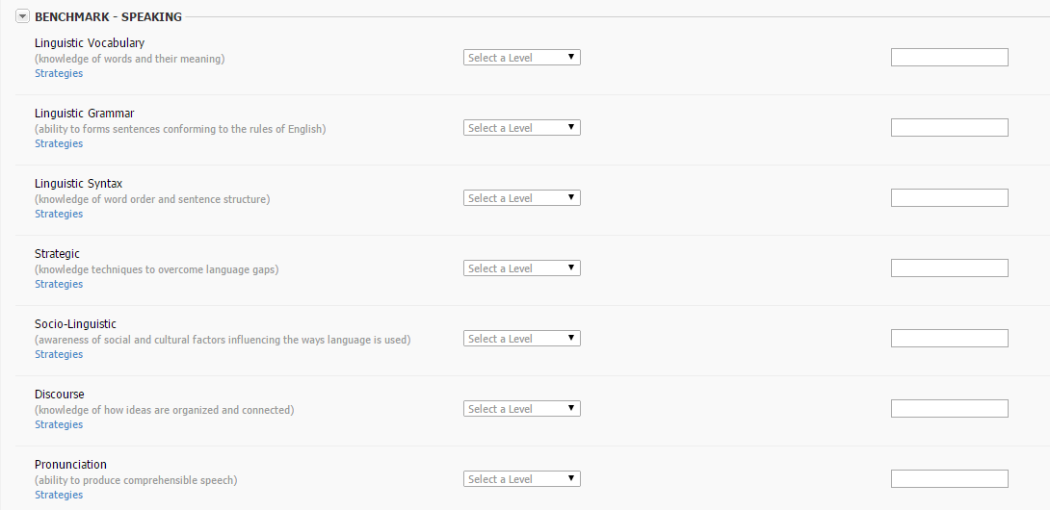
- Linguistic Vocabulary (knowledge of words and their meaning)
  - LEVEL 1 Beginning
    - Uses a few words (i.e., approximately 1500), including:
      - Utility words
      - Descriptive words
    - Encountered in class
  - LEVEL 2 Develping
    - Uses some words (i.e., approximately 2000), including:
      - Utility words
      - Descriptive words
  - LEVEL 3 Expanding
    - Uses more words (i.e., approximately 4000), including:
      - Utility words
      - Descriptive words
      - Subject-specific words
  - LEVEL 4 Bridging
    - Uses arrange of words (i.e., approximately 7500), including:
      - Utility words
      - Descriptive words
      - Subject-specific words
  - LEVEL 5 Extending
    - Understands a broad range of words (i.e., approximately 10,000), including:
      - Utility words
      - Descriptive words
      - Subject-specific words
    - Has an understanding of concepts expands
- Linguistic Grammar (ability to form sentences conforming to the rules of English)
  - LEVEL 1 Beginning
    - Uses:
      - Pronouns
      - Adjectives
      - Adverbs
      - Nouns
      - Verbs
    - With word-order errors and word-ending omissions
  - LEVEL 2 Developing
    - Uses:
      - Pronouns
      - Plurals
      - Nouns
      - Verbs
    - With over generalization of:
      - –sendings
      - –edendings
  - LEVEL 3 Expanding
    - Uses:
      - Pronouns
      - Adjectives
      - Adverbs
      - Nouns
      - Verbs
    - With some agreement and tense errors
  - LEVEL 4 Bridging
    - Uses:
      - Irregular plurals
      - Nouns
      - Verb-word forms
    - With occasional errors
  - LEVEL 5 Extending
    - Adjusts word forms for:
      - Appropriate tense
      - Agreement
    - With increasing accuracy
- Linguistic Syntax (knowledge of word order and sentence structure)
  - LEVEL 1 Beginning
    - Uses:
      - One or more words
      - Memorized phrases
  - LEVEL 2 Developing
    - Uses:
      - Simple sentences
  - LEVEL 3 Expanding
    - Uses positive and negative
      - Questions
      - Statements
      - Commands
  - LEVEL 4 Bridging
    - Adds more detail to
      - Questions
      - Statements
      - Commands
  - LEVEL 5 Extending
    - Uses:
      - Simple compound
      - Complex
    - Sentence structures
- Strategic (knowledge techniques to overcome language gaps)
  - LEVEL 1 Beginning
    - Interacts using:
      - First language
      - Memorized phrases
      - Copied phrases
    - Relies on:
      - Visual prompts
      - Gestures
  - LEVEL 2 Developing
    - Interacts spontaneously with peers and adults using:
      - Familiar phrases
  - LEVEL 3 Expanding
    - Communicates using strategies, such as:
      - Circumlocution
      - Providing examples
      - Providing opposites
  - LEVEL 4 Bridging
    - Initiates and sustains a conversation with peers and adults by:
      - Commenting
      - Making personal connection
      - Questioning
  - LEVEL 5 Extending
    - Initiates and sustains communicative tasks by:
      - Paraphrasing
      - Commenting
      - Making personal connection
      - Questioning
- Socio-Linguistic (awareness of social and cultural factors influencing the ways language is used)
  - LEVEL 1 Beginning
    - Uses familiar:
      - Greetings
      - Courtesy phrases
      - Gestures
    - To interact in familiar social contexts
  - LEVEL 2 Developing
    - Uses some common:
      - Expressions
      - Gestures
    - To interact in familiar social and classroom context
  - LEVEL 3 Expanding
    - Uses common:
      - Expressions
      - Slang
      - Idioms
    - When interacting with peers and adults
  - LEVEL 4 Bridging
    - Uses:
      - Common phrasal verbs
    - Inappropriate contexts
  - LEVEL 5 Extending
    - Adjusts speech
      - Informal and informal situations
    - When interacting with peers and adults
- Discourse (knowledge of how ideas are organized and connected)
  - LEVEL 1 Beginning
    - Combines one or more words and connects words with:
      - “and.”
  - LEVEL 2 Developing
    - Connects words in phrases and/or short simple sentences with:
      - Common conjunctions
  - LEVEL 3 Expanding
    - Connects ideas in sentences with:
      - Conjunctions
      - Time marks
  - LEVEL 4 Bridging
    - Connects ideas in related sentences with:
      - Conjunctions
      - Time marks
      - Sequence markers
  - LEVEL 5 Extending
    - Connects ideas in more complex sentences with
      - A variety of cohesive devices
- Pronunciation (ability to produce comprehensible speech)
  - LEVEL 1 Beginning
    - Imitate some:
      - English sounds
    - In:
      - Familiar routines
    - Although pronunciation errors may interfere with meaning
  - LEVEL 2 Developing
    - Approximates:
      - English rhythm
      - Stress
      - Intonation
    - In:
      - Familiar social and classroom routines
    - Although pronunciation errors may interfere with meaning
  - LEVEL 3 Expanding
    - Uses:
      - Comprehensible pronunciation
      - Appropriate rhythm
      - Appropriate intonation
    - In:
      - Familiar and rehearsed actives
    - Although errors may still occur
  - LEVEL 4 Bridging
    - Uses:
      - Comprehensible pronunciation
      - Appropriate intonation
    - In:
      - Familiar and rehearsed activities
    - With occasional errors
  - LEVEL 5 Extending
    - Uses:
      - Comprehensible pronunciation
      - Intonation
    - Within creasing accuracy in:
      - Unrehearsed situations where dialogue is spontaneous
    - (accented speech is expected and accepted)

BENCHMARK – READING
- Linguistic Vocabulary (knowledge of words and their meaning)
- LEVEL 1 Beginning
    - Understands safe words (i.e., approximately 1500), including:
      - Utility words
      - Descriptive words
    - Associated with environmental print and classroom words and labels
    - Names letters of the alphabet
    - Acquires some sight words.
- LEVEL 2 Developing
- Understands some words (i.e., approximately 2000), including:
  - Utility words
  - Descriptive words
  - Subject-specific words
- LEVEL 3 Expanding
  - Understands more words (i.e., approximately 4000), including:
- Utility words
- Descriptive words
- Subject-specific words
- LEVEL 4 Bridging
  - Understands arrange of words (i.e., approximately 7500), including:
    - Words with multiple meanings
  - Applies contextual guessing to understands texts
- LEVEL 5 Extending
  - Understands a broad range of words (i.e., approximately 10,000), including:
    - Most subject-specific words
  - Applies word knowledge to understand texts
- Linguistic Syntax (knowledge of word order and sentence structure)
  - LEVEL 1 Beginning
    - Identifies:
      - Objects
      - Actions
    - In simple sentences
  - LEVEL 2 Developing
    - Understands elements of:
      - Simple sentences
  - LEVEL 3 Expanding
    - Understands:
      - Detail sentences
  - LEVEL 4 Bridging
    - Understands that word order impacts:
      - Meaning
  - LEVEL 5 Extending
    - Understands that word order impacts:
      - Tone
      - Mood
      - Emphasis
- Strategic Decoding (ability to read words by sounding them out)
  - LEVEL 1 Beginning
    - Recognizes most:
      - Sounds/symbol relationships
  - LEVEL 2 Developing
    - Uses:
      - Phonemic awareness
    - To:
      - Identify sight words
      - Decode using beginning sounds
  - LEVEL 3 Expanding
    - Uses:
      - Phonemic awareness
    - To decode:
      - Ending sounds
      - Consonant blends
      - Digraphs
      - Simple word families
  - LEVEL 4 Bridging
    - Uses:
      - Phonemic awareness
      - Chunking
    - To decode:
      - Long and short vowels in medial positions
      - More complex word families
  - LEVE 5 Extending
    - Uses:
      - Phonemic awareness
      - Chunking
    - To decode:
      - Vowel blends
      - R-controlled vowels
      - Tow-or three-syllable words
- Strategic Comprehension (ability to apply techniques and tools to construct meaning)
  - LEVEL 1 Beginning
    - Matches:
      - Words
      - Pictures
    - To make meaning
  - LEVEL 2 Developing
    - Relies on:
      - Label diagrams
      - Illustrations
    - To understand new words
  - LEVEL 3 Expanding
    - Relies on:
      - Familiar phrases
      - Pattered sentences
      - Shared experiences
    - To predict meaning
  - LEVEL 4 Bridging
    - Uses:
      - Contextual cues
      - Visual cues
    - To comprehend texts on familiar topics
  - LEVEL 5 Extending
    - Uses:
      - Rereading
      - Self-correction
      - Prediction
      - Word analysis
      - Visual cues
    - To comprehend texts on unfamiliar topics
- Socio-Linguistic (awareness of social and cultural factors influencing the ways language is used)
  - LEVEL 1 Beginning
    - Understands:
      - Shared reading experiences
  - LEVEL 2 Developing
    - Understands:
      - Simple texts literally
  - LEVEL 3 Expanding
    - Understand that text can have:
      - Literal meaning
      - Figurative meaning
  - LEVEL 4 Bridging
    - Understand the figurative meaning of some:
      - Simple phrasal verbs
      - Similes
  - LEVEL 5 Extending
    - Understands simple cultural references, such as:
      - Idioms
      - Metaphors
      - Humour
- Discourse (knowledge of how ideas are organized and connected)
  - LEVEL 1 Beginning
    - Understands
      - Simple patterned sentences
    - On familiar topics
  - LEVEL 2 Developing
    - Understands:
      - Simple sentences
    - Connected with:
      - Common conjunctions
      - Prepositions
      - Time markers
    - On familiar topics
  - LEVEL 3 Expanding
    - Understands:
      - Main ideas
    - Of related sentences connected with:
      - Conjunctions
      - Time marks
    - On familiar topics
  - LEVEL 4 Bridging
    - Understands:
      - Main ideas
      - Some details
    - Of related sentences connected with:
      - Conjunctions
      - Time markers
      - Sequence markers
    - On familiar topics
  - LEVEL 5 Extending
    - Understands:
      - Main ideas
      - Details
    - Of paragraphs connected with:
      - A variety of cohesive devices
    - On unfamiliar topics
- Fluency (knowledge of how ideas are organized and connected)
  - LEVEL 1 Beginning
    - Reads:
      - Letter-by-letter to sound out words
  - LEVEL 2 Developing
    - Reads:
      - Word-by-word
      - With pausing to refer to visuals
  - LEVEL 3 Expanding
    - Reads:
      - With some phrasing
      - With some rereading
      - Sounding out words
  - LEVEL 4 Bridging
    - Reads:
      - With some expression
      - By substituting unknown words with familiar words
      - With some self-correction
  - LEVEL 5 Extending
    - With expression
      - With attention to common punctuation
      - Making meaningful substitutions

BENCHMARK – WRITING
- Linguistic Vocabulary (knowledge of words and their meaning)
  - LEVEL 1 Beginning
    - Use safe words (i.e., approximately 1500), including:
      - Sight words
      - A few utility words
      - A few descriptive words
    - Related to familiar objects and personal experiences
  - LEVEL 2 Developing
    - Use some words (i.e., approximately 2000), including:
      - Utility words
      - Descriptive words
      - Subject-specific words
    - Related to familiar objects, actions and topics
  - LEVEL 3 Expanding
    - Uses more words (i.e., approximately 4000), including:
      - Utility words
      - Descriptive words
      - Subject-specific words
    - Related to curricular concepts
  - LEVEL 4 Bridging
    - Use a range of words (i.e., approximately 7500), including:
- Synonyms
- Words with multiple meanings

    - Related to curricular concepts
  - LEVEL 5 Extending
    - Uses a broad range of words (i.e., approximately 10,000), including:
      - Utility words
      - Descriptive words
      - Subject-specific words
      - Academic words
    - Related to curricular concepts
- Linguistic Grammar (ability to form sentences conforming to the rules of English)
  - LEVEL 1 Beginning
    - Writes:
      - Nouns
      - Verbs in present tense
      - Prepositions
    - To complete:
      - Sentence frames
  - LEVEL 2 Developing
    - Writes:
      - Nouns
      - Verbs in simple paste tense
      - Prepositions
      - Plurals
    - With tense errors and omissions
  - LEVEL 3 Expanding
    - Writes:
      - Nouns
      - Verbs in irregular past and continuous tenses
      - Prepositions
      - Pronouns
      - Articles
      - Adjectives
      - Adverbs
    - With usage errors
  - LEVEL 4 Bridging
    - Writes:
      - Arrange of grammar structures
    - Demonstrating some control of:
      - Word order
      - Plurals
      - Tenses
      - Subject-verb agreement
  - LEVEL 5 Extending
    - Writes:
      - A range of grammar structures
    - Demonstrating more control of:
      - Word order
      - Plurals
      - Tenses
      - Subject-verb agreement
- Linguistic Syntax (knowledge of word order and sentence structure)
  - LEVEL 1 Beginning
    - Write:
      - A range of grammar structures
    - Demonstrating more control of:
      - Word order
      - Plurals
      - Tenses
      - Subject-verb agreement
  - LEVEL 2 Developing
    - Writes
      - Simple sentences
      - Patterned sentences
    - Independently
  - LEVEL 3 Expanding
    - Writes:
      - Simple detailed sentences
      - Compound sentences
  - LEVEL 4 Bridging
    - Writes
      - Complex sentences
      - Simple paragraphs
  - LEVEL 5 Extending
    - Writes:
      - A variety of sentence types
      - Detailed paragraphs
- Strategic (awareness of social and cultural factors influencing the ways language is used)
  - LEVEL 1 Beginning
    - Copies word with increasing accuracy
  - LEVEL 2 Developing
    - Attempts to spell familiar words
  - LEVEL 3 Expanding
    - Invents spelling that reflects learner’s own pronunciation
  - LEVEL 4 Bridging
    - Spells words according to:
      - Pronunciation
      - Knowledge of common spelling patterns
  - LEVEL 5 Extending
    - Spells challenging words using strategies, such as:
      - Phonic memory
      - Visual memory
- Socio-Linguistic (awareness of social and cultural factors influencing the ways language is used)
  - LEVEL 1 Beginning
    - Copies:
      - Group-generated texts
      - Pattern sentences
    - With little or no understanding of audience and purpose
  - LEVEL 2 Developing
    - Copies:
      - Group-generated texts
    - Completes:
      - Pattern sentence frames
    - With some understanding of topic, audience and purpose
  - LEVEL 3 Expanding
    - Creates text using:
      - Appropriate templates to express cultural norms
    - Completes:
      - Graphic organizers
      - Writing plant templates
  - LEVEL 4 Bridging
    - Creates texts on specific topics using:
      - Templates as a guide
    - Completes:
      - Graphic organizers
      - Writing plan templates
    - With some support
  - LEVEL 5 Extending
    - Creates appropriate texts demonstrating a sense of:
      - Topic
      - Purpose
      - Style
      - Register
- Discourse (knowledge of how ideas are organized and connected)
  - LEVEL 1 Beginning
    - Connects:
      - Two or more words
    - Substitutes:
      - Words in patterned sentences
    - With support
  - LEVEL 2 Developing
    - Connects words in simple sentences with:
      - “and” or “then.”
  - LEVEL 3 Expanding
    - Connects ideas in short, related sentences with:
      - Conjunctions
      - Time markers
  - LEVEL 4 Bridging
    - Connects ideas in sentences using a range of:
      - Conjunctions
      - Time marks
      - Sequence marks
  - LEVEL 5 Extending
    - Produces sequence and organized text using:
      - A variety of cohesive devices effectively
- Editing (ability to identify and correct writing errors, improve word choice and make sentences clearer)
  - LEVEL 1 Beginning
    - Edits:
      - Sight words for spelling
    - With direct support
  - LEVEL 2 Developing
    - Edits for:
      - Capitals at the beginning of sentences
      - Periods at the end of sentences
      - Spelling of familiar words
    - With some support
  - LEVEL 3 Expanding
    - Edits for:
      - Capitals
      - End of sentence punctuation
      - Commas in a list
      - Regular spelling
    - Independently
  - LEVEL 4 Bridging
    - Edits sentences for:
      - Common punctuation
      - Simple tenses
      - Regular spelling
  - LEVEL 5 Extending
    - Edits sentences for:
      - Regular punctuation
      - A variety of tenses
      - Common irregularly spelled words

Below the 4 categories are options to
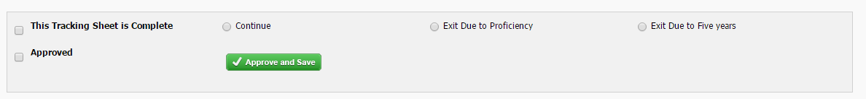
- This Tracking Sheet is Complete
- Continue
- Exit Due to Proficiency
- Exit Due to Five years
- Approved
  - Approve and Save

GB +
This benchmark contains 3 sub sections.

Results
- Did the student achieve their Grade Level Target?
  - Yes
  - No
- Did the student achieve their Year Growth Target?
  - Yes
  - No

Grade Level Targets
- What is the student’s targets level?
  - 1 to 30
- What is the grade level year-end target?
  - 1 to 30

Results Table
- Term – the term this assessment was conducted.
- Literal Comprehension
- Deductive Comprehension
- Text Recall
- Reading Level
- Fluency
- Strategies Mastered – Can contain up to 5000 characters.
- Strategies Targeted – Can contain up to 5000 characters
- Result
  - Add Test Result

Classroom Profile
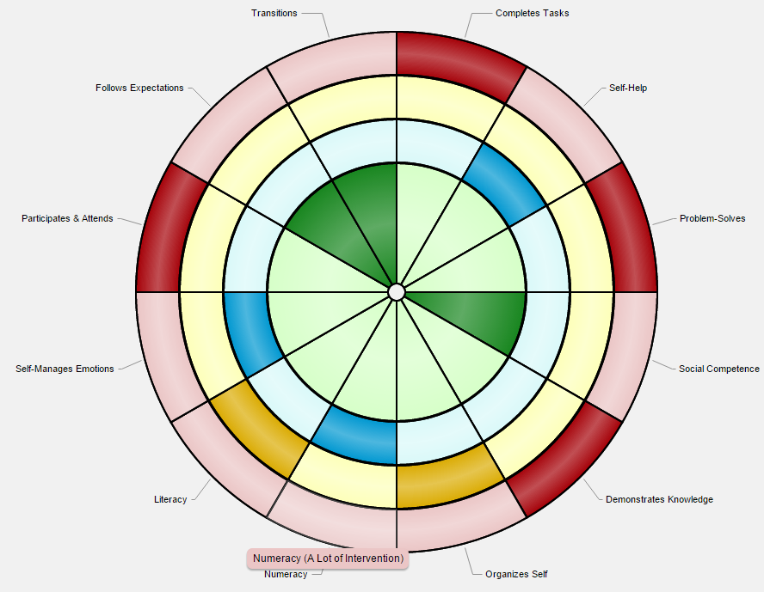

Comments
This area allows for the creation of comments regarding the student’s benchmarks.
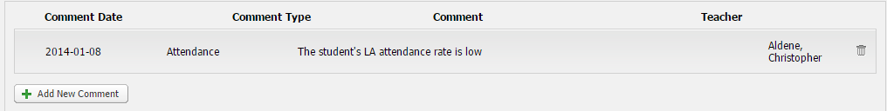
- Comment Date – Date of the comment or date regarding to the testing.
- Comment Type – There are 3 types of comments:
  - Learning Style
  - Attendance
  - Achievement
- Comment – The actual comment.
- Teacher – Who entered or updated the comment. This is automatically populated.
- Add New Comment

Diploma
The Diploma area is essentially a dashboard showing a summary of all Diploma testing results that are entered into the system. You are able to see summary data for the entire District, by School, and by students. To get to this area, click on Diploma on the home screen whish loads immediately after logging in to the system
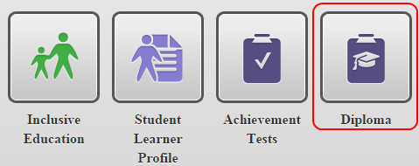
After following the Diploma link, a new page will load with a few more options at the top with Summaries loading by default.
At the top of the Summaries screen, there are a few drop down lists that will narrow down exactly what summary information is needed. By default, the district is loaded. Simply narrow down this criteria to exactly what summary data is needed.
- Test Term – The term, or time frame, of testing data and school year. The number of terms varies depending on how long the system has been used.
- Course Code – All the different diploma courses.
- Location – Contains a list of all schools at the district.

Select Filter
By clicking on Select Filter, a small popup window loads showing a few other filtering options to add.
- Gender – Allows the separation of diploma results between Male and Female.
- Coded – Show only results for students that are coded, meaning students that have an ISP.
- FNMI – First Nation Metis and Inuit: show diploma results for aboriginal students.
- ELL – English Language Learners: Show only results for students whose first language is not English.
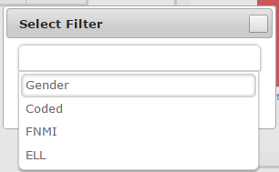
To add one of these filter options, click on the item in the list and it will automatically appear in the filter list as an option. Multiple can be added as needed.

Report Level
The Report Level allows the page view to be switched between a summary of Diploma marks and Categories.

General

Table 1 – Participation Report
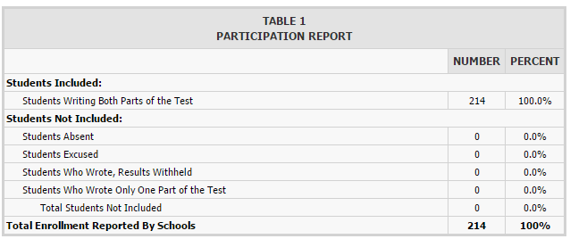
This table summarized the participation for the diploma testing, both count and percentage, broken down into a few sub-categories:
- Students Included
  - Student Writing Both Parts of the Test
- Students Not Included
  - Students Absent
  - Students Excused
  - Students Who Wrote, Results Withheld
  - Students Who Wrote Only One Part of the Test
    - Total Students Not Included
- Total Enrollment Reports By Schools

Table 1 Chart
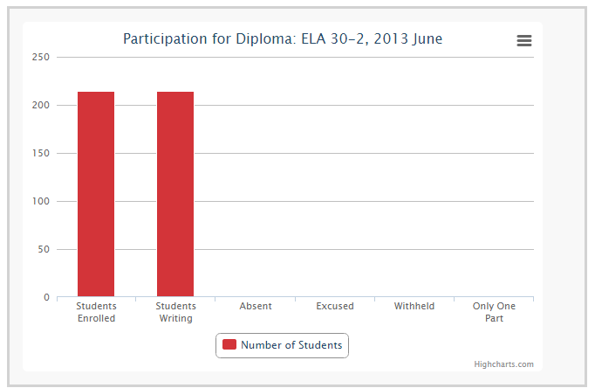
This bar chart is a visual representation of the count of students for each sub-category: Students Enrolled
- Students Writing
- Absent
- Excused
- Withheld
- Only One part
Clicking on any of the bars will open a student list drill down to help identify the specific students in the sub-category. This list can be exported in both PDF and Excel formats for ease of use. Also, clicking on a student in this list will open their Diploma dashboard.
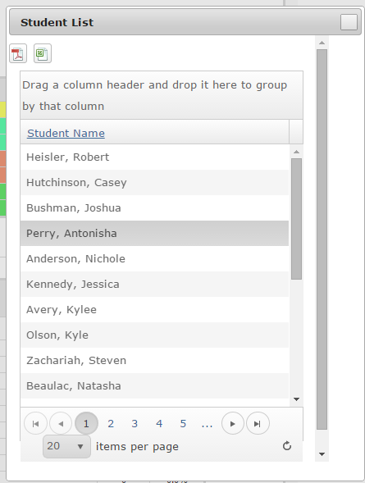

Student Margins
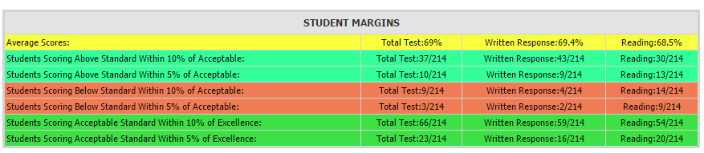
The Student Margins table summarizes the total scores broken up by testing categories for all students. The table also breaks down these results further by showing the summary of who fell within 5% and 10% of Above, Below, and Acceptable standards.
- Average Scores
- Total Test
- Written Response
- Reading

Table 2.1 – Standards Demonstrated By All Students
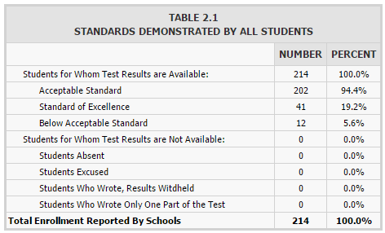
The Standards Demonstrated By All Students table breaks down how many students fall under Acceptable, Excellence, and Below. Slightly different view from the Student Margins table.
- Students for Whom Test Results are Available
  - Acceptable Standard
  - Standard of Excellence
  - Below Acceptable Standard
- Students for Whom Test Results are Not Available
  - Students Absent
  - Students Excused
  - Students Who Wrote, Results Withheld
  - Students Who Wrote Only One Part of the Test
- Total Enrollment Reported By Schools

Table 2.1 Chart
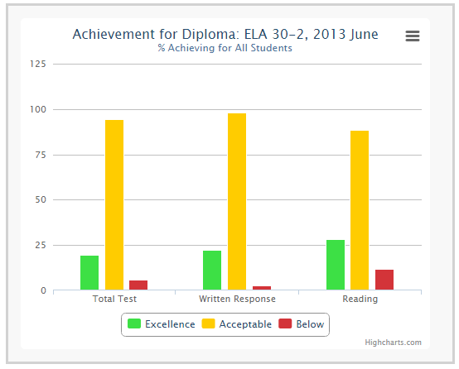
The Achievement for Diploma bar chart is a visual representation that is similar to the Standards Demonstrated by All Students table but also goes one step further and shows the count between the 2 different parts of Diploma testing.
- Total Test
- Written Response
- Reading
Clicking on any of the bars will open a student list drill down to help identify the specific students in the sub-category. This list can be exported in both PDF and Excel formats for ease of use. Also, clicking on a student in this list will open their Diploma dashboard.
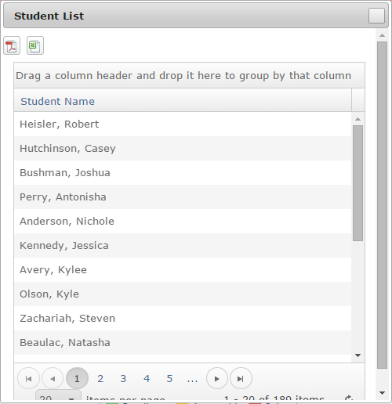

Table 2.2 – Standards Achieved By Students Writing the Test, By Reporting Category
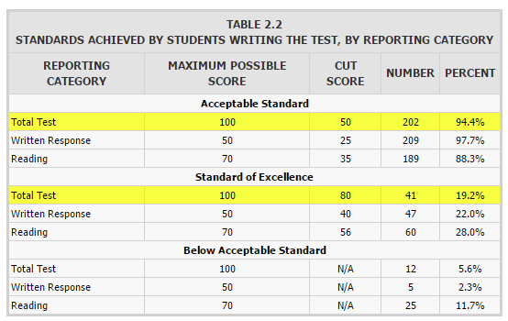
Table 2.2 breaks down these results even further by showing the results for each category of the test, Written and Reading for each score (Acceptable, Excellence, Below). The table also shows what the Cut score is for each category, the number of students who completed the section, and the average, in percent.

Table 2.2 Chart
The Achievement for Diploma bar chart is a visual representation that is similar to the Standards Demonstrated by All Students table but also goes one step further and shows the count between the 2 different parts of Diploma testing.
- Total Test
- Written Response
- Reading
Clicking on any of the bars will open a student list drill down to help identify the specific students in the sub-category. This list can be exported in both PDF and Excel formats for ease of use. Also, clicking on a student in this list will open their Diploma dashboard.

Table 2.3 – Standards Achieved By Students Writing the Test, By Reporting Category
Table 2.2 goes one step further in breaking down the results. Instead of totals for Acceptable, Excellence, and Below, this table breaks down the results by Grade level. So we see A (80% - 100%), B (65% - 79%), C (50% - 64%), and F (0% - 49%). It also shows the Cut Score, Number of Students falling under a category, and average percentage.

Table 2.3 Chart
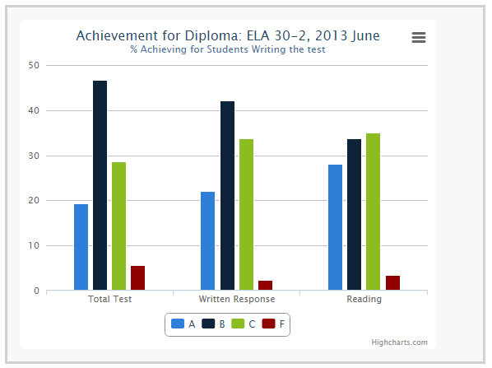
The Achievement for Diploma bar chart is a visual representation of Table 2.4.
- Total Test
- Written Response
- Reading
Clicking on any of the bars will open a student list drill down to help identify the specific students in the sub-category. This list can be exported in both PDF and Excel formats for ease of use. Also, clicking on a student in this list will open their Diploma dashboard.
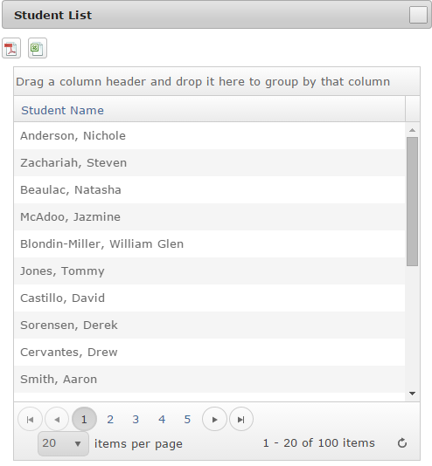

Categories
Each of the following categories represent data in a unique way to help show the average scores among the different sections of the test and even individual questions. This can also help identify what sections and/or questions scored the lowest and highest among the students.
Each category shows the results based off the following color coding:
- Exceptional
- Strength
- Acceptable
- Low
- Concern

Reporting Category
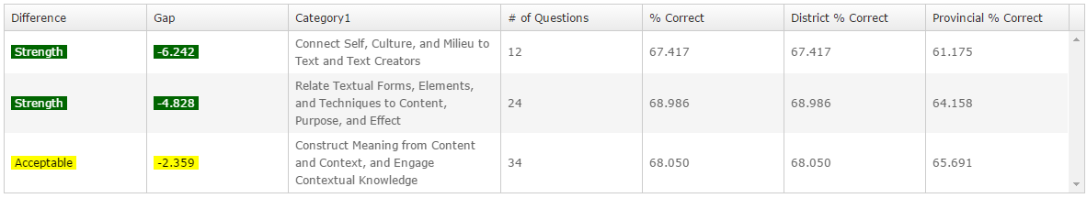
- Difference – Shows the value based off the results table above as to where this this area averaged.
- Gap – The score this area was averaged. Also color coded to match table above.
- Category 1 – The name of the category in from the testing.
- # of Questions – The count of questions that were in the category.
- % Correct – Average percentage between all students at the selected school that answered correctly in this category.
- District % Correct – Average percentage between all students at the district that answered correctly in this category.
- Provincial % Correct - Average percentage between all students in the province that answered correctly in this category.

Reporting Category 2
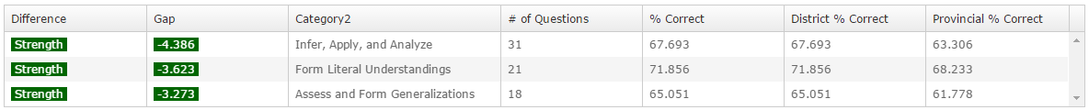
- Difference – Shows the value based off the results table above as to where this this area averaged.
- Gap – The score this area was averaged. Also color coded to match table above.
- Category 1 – The name of the category in from the testing.
- # of Questions – The count of questions that were in the category.
- % Correct – Average percentage between all students at the selected school that answered correctly in this category.
- District % Correct – Average percentage between all students at the district that answered correctly in this category.
- Provincial % Correct - Average percentage between all students in the province that answered correctly in this category.

Reporting Category & Category 2
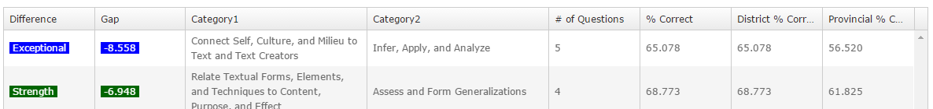
This sub-section breaks down the testing by Category 1 and Category 2 as Category 2 can be included in multiple Category 1 questioning.
- Difference – Shows the value based off the results table above as to where this this area averaged.
- Gap – The score this area was averaged. Also color coded to match table above.
- Category 1 – The name of the category in from the testing.
- Category 2 – The name of category 2 from the testing.
- # of Questions – The count of questions that were in the category.
- % Correct – Average percentage between all students at the selected school that answered correctly in this category.
- District % Correct – Average percentage between all students at the district that answered correctly in this category.
- Provincial % Correct - Average percentage between all students in the province that answered correctly in this category.

Individual Questions
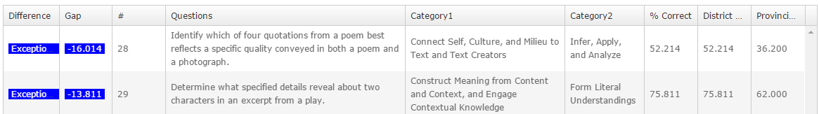
- Difference - Shows the value based off the results table above as to where this this area averaged.
- Gap - The score this area was averaged. Also color coded to match table above.
- # - The actual number of the question as it appeared in the test.
- Questions – The actual questions text.
- Category 1 - The name of the category in from the testing.
- Category 2 - The name of category 2 from the testing.
- % Correct - Average percentage between all students at the selected school that answered correctly in this category.
- District % Correct – Average percentage between all students at the district that answered correctly in this category.
- Provincial % Correct - Average percentage between all students in the province that answered correctly in this category.

