10 Effective Practices for Teaching Reading

- Focus on Meaning- Comprehension is the number one, most important goal of reading! Reading Comprehension Strategies that work.
- Read Aloud- Students learn as they listen to someone read, especially with texts that are too difficult for them. Benefits are building vocabulary, developing understanding, supporting developing connections between print elements, modeling fluency, motivating students to read and may more! Click here for a strategy guide on Read Aloud. Read Aloud Tutorial Part one. Read Aloud Tutorial Part Two.
- Create Independent Readers Who Love to Read- Like anything else, the best way to master reading is by practicing it! Provide students with time to read quietly and independently every day. Allow students to choose the books that they want to read, diverse topics, diverse genres and diverse levels.
- Give Beginning Readers Lots of Opportunities to Interact with Print- Beginning readers need lots of practice with alphabet and sounds, sight words, word work, phonics and rhyming. 5 tips for beginning readers.
- Provide a Rich Array of Print Choices- Make sure readers have poetry, magazines, newspapers, trade books, graphic novels and other real-world options too.
- Give Students Choice in What They Read- Who chooses the books that you like to read? If we want kids to have a lifelong love of reading, we need to give them practice at choosing texts that interest them- just as we do! Article on choice and engagement.
- Give Students Daily Opportunities to Talk About Their Reading- Students need a chance to share favorites with one another and recommend books to their peers, this builds a sense of community around reading. Talking represents the student’s thinking. We engage students in conversation that is grounded in a variety of texts- those that students read, hear, or write- and that expands their ability to comprehend ideas and use language to share thinking.
- Teach Reading as Thinking- Comprehension strategies are conscious plans — sets of steps that good readers use to make sense of text. Comprehension strategy instruction helps students become purposeful, active readers who are in control of their own reading comprehension. These seven strategies have research-based evidence for improving text comprehension. Comprehension strategies (Reading Rockets)
- Support Readers Before, During and After Reading- Frontload comprehension strategies before reading, monitor students’ understanding during reading, then provide time for students to savor their reading and connect it to other experiences. Help them make the connections of Thinking Within the Text, Thinking About the Text, and Thinking Beyond the Text. For examples on before, during and after reading planning, click here.
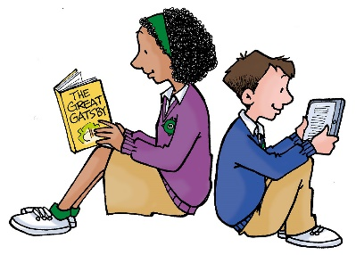
- Name, Teach, Model Reading Strategies Directly- Don’t keep reading strategies a secret. Be sure to explicitly label strategies as you model them.

More Resources

Book : Teaching Reading in Middle School: A Strategic Approach to Teaching Reading that Improves Comprehension and Thinking.

Cracking the Reading Code with the Brain-In-Mind http://thesecretstories.com/

Teaching Reading in Small Groups: https://www.heinemann.com/shared/onlineresources/E02680/Serravallo_WEB%20chap.pdf
Different Ideas to Engage Readers in the Classroom: 12 ways to Engage Readers.docx
Guided Reading Example K-2 Scholastic: http://teacher.scholastic.com/products/next-step-guided-reading-assessment/pdfs/NSGRA_Sample_K-2_Lesson_Plan.pdf
Reading Comprehension for Adolescents: http://www.adlit.org/adlit_101/improving_literacy_instruction_in_your_school/reading_comprehension/
How Can I Help Older Students Improve with Reading Comprehension? http://www.adlit.org/adlit_101/improving_literacy_instruction_in_your_school/reading_comprehension/

